**INTI International College Penang School of Engineering and Technology**

**3+0 Bachelor of Science (Hons) in Computer Science, in collaboration with Coventry University, UK**

**3+0 Bachelor of Science (Hons) in Computing, in collaboration with Coventry University, UK**

**Coursework cover sheet**

**Section A - To be completed by the student**

|  |  |
| --- | --- |
| Full Name: Chan Kok Han | |
| CU Student ID Number: P21013717 | |
| Semester: 3 | |
| Session:  **April 2022** | |
| Lecturer:  **Nadhrah Abdul Hadi (nadhrah.abdulhadi@newinti.edu.my)** | |
| Module Code and Title:  **4067CEM Software Design** | |
| Assignment No. / Title:  **Continuous Assessment** | % of Module Mark:  **50** |
| Hand out Date:  **22nd April 2022** | Due Date:  **Task 1: 13 May 2022, by 11.59pm**  **Task 2: 1 July 2022, by 11.59pm**  **Task 3: 17 June 2022, by 11.59pm.**  **Task 4: 17 June 2022, by 11.59pm.**  **Task 5: 17 June 2022, by 11.59pm.** |
| Penalties: No late work will be accepted. If you are unable to submit coursework on time due to extenuating circumstances, you may be eligible for an extension. Please consult the lecturer. | |
| Declaration: I/we the undersigned confirm that I/we have read and agree to abide by the University regulations on plagiarism and cheating and Faculty coursework policies and procedures. I/we confirm that this piece of work is my/our own. I/we consent to appropriate storage of our work for plagiarism checking.  Signature(s): Han | |

**Section B - To be completed by the module leader**

|  |  |  |
| --- | --- | --- |
| Intended learning outcomes assessed by this work:  1. Understand and apply appropriate concepts, tools and techniques to each stage of the software development  2. Understand and apply design patterns to software components in developing new software  3. Demonstrate an understanding of project planning and working to agreed deadlines, along with professional, interpersonal skills and effective communication required for software production  5. Demonstrate an awareness of, and ability to apply, social, professional, legal and ethical standards as documented in relevant laws and professional codes of conduct such as that of the Malaysian National Computer Confederation. | | |
| Marking scheme | Max | Mark |
| 1. User Story Mapping 2. Setting up a GitHub Repository 3. Creating a Class diagram and design pattern selection 4. Creating a Prototype User Interface and Usability Testing 5. Discuss the ethical issue related to the software | 20  10  30  20  20 |  |
| Total | 100 |  |

# Prototype User Interface

There are three main functions of the College Events System for Students below.

1. **Login**

The login function is commonly significant for all website developments to identify the users before they can proceed to the website. It will allow users to have site access and the event organiser/Admin user access to the website to see and track the user actions and behaviours.

Users must have the correct username and password combination for authentication to access their details, and password authentication relies on a secret value known only to the user.

For a website using only a username without password authentication, anyone who knew their email address, for instance, could log in to any of their online accounts, including bank and email accounts, would be matched by the users.

It has the option to sign up for the account if they do not have one by filling in names, emails, and passwords. It has the “Forget Password” option to create a new password if they forget their password.

**Login Page**

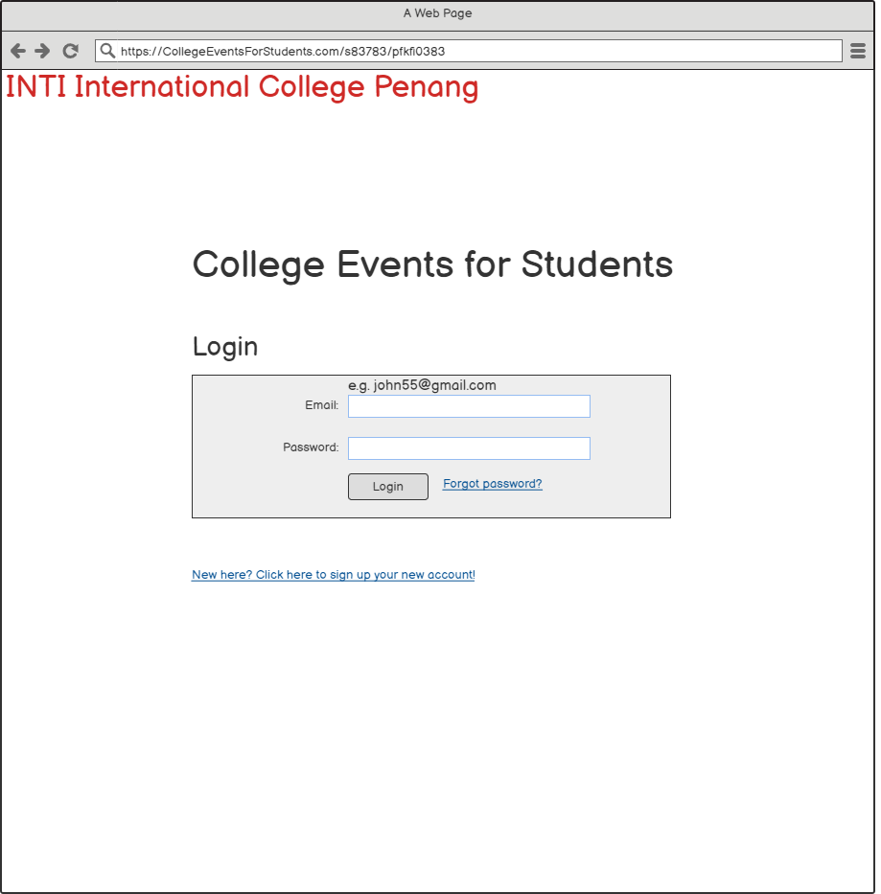

**Sign Up**

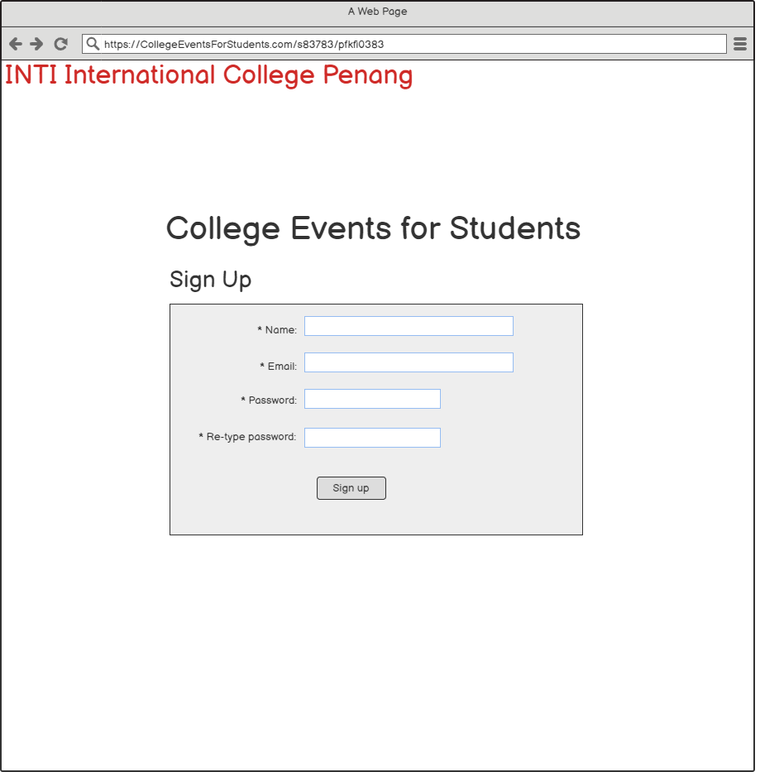

**Setting Up New Password**

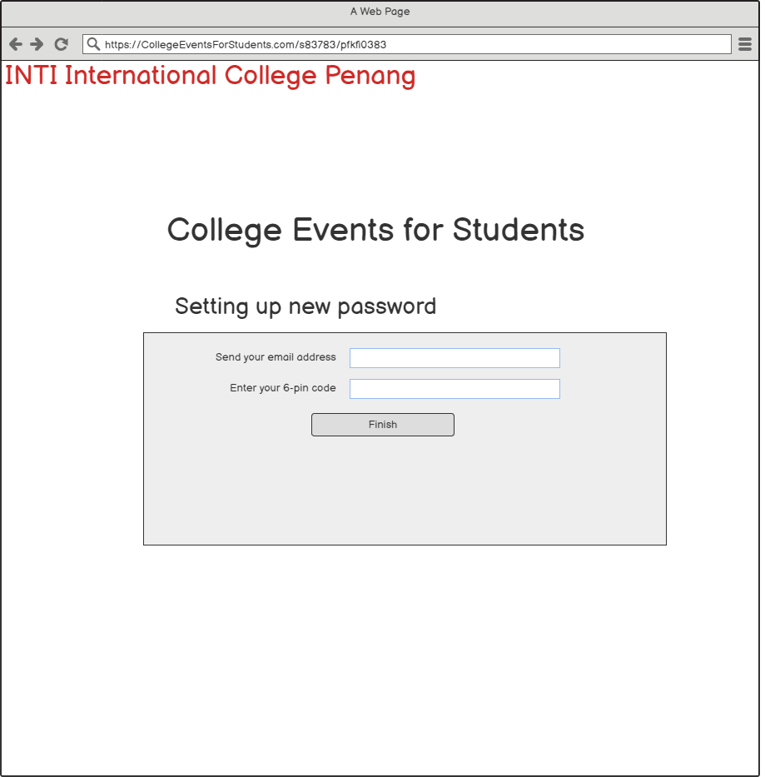

**Forgot Password**

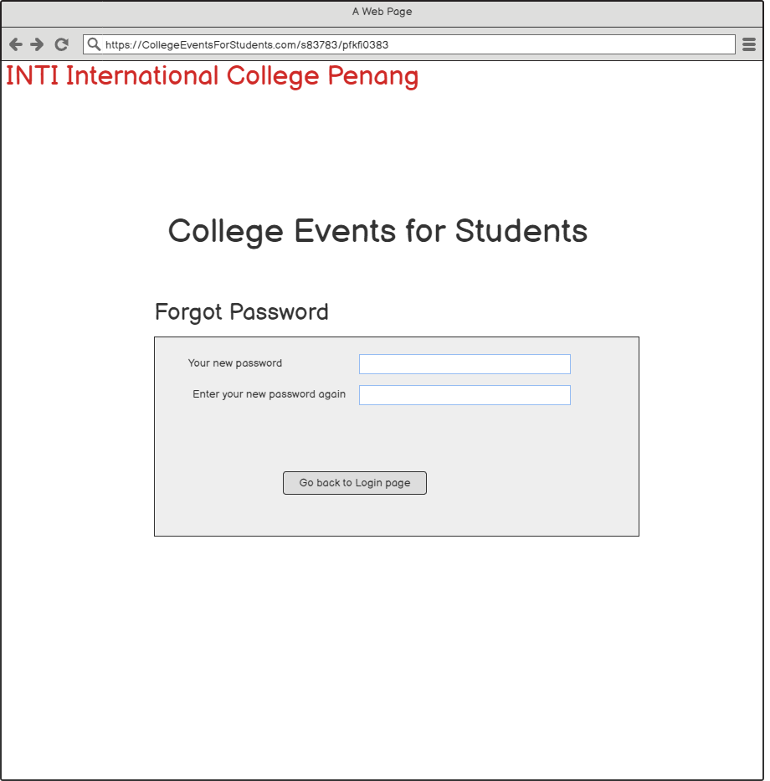

1. **Search Box**

It helps the users search for keywords or phrases of the likely answers and outcomes without searching an entire website. It ensures that users find the results quickly and easily. For example, a user types out Book Event inside the search box and searches for the results.

If a user wants to see the past events, click the category Past Events to see the past ones.

If a user wants to know about the current events, click the category Current Events to see the current ones.

If a user wants to know about the upcoming events, click the category Upcoming Events to see the upcoming ones.

If a user wants to see and search for the type of events, click the Event Categories. Then, for instance, clicking Board Games leads to Chess is valuable for the College Event for Students system as the users need to click and search the results in less time.

If a user wants to search for a specific date about the events, click the Date to see the event.

**Event Searching**

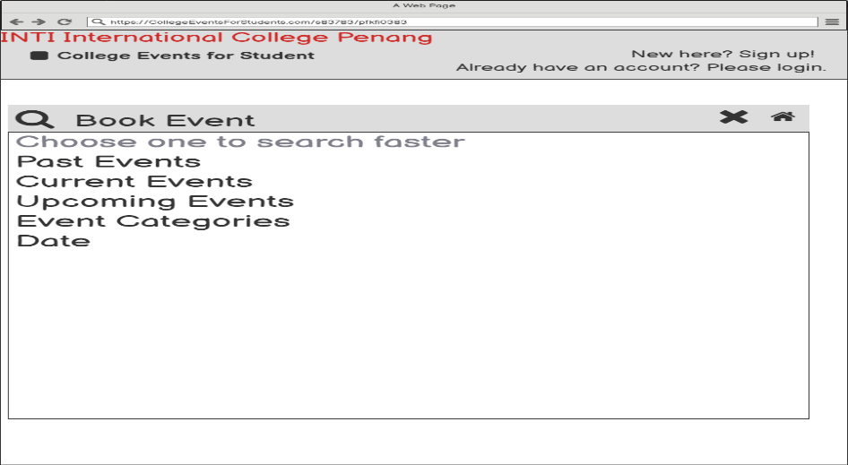

**Event Searching Results**

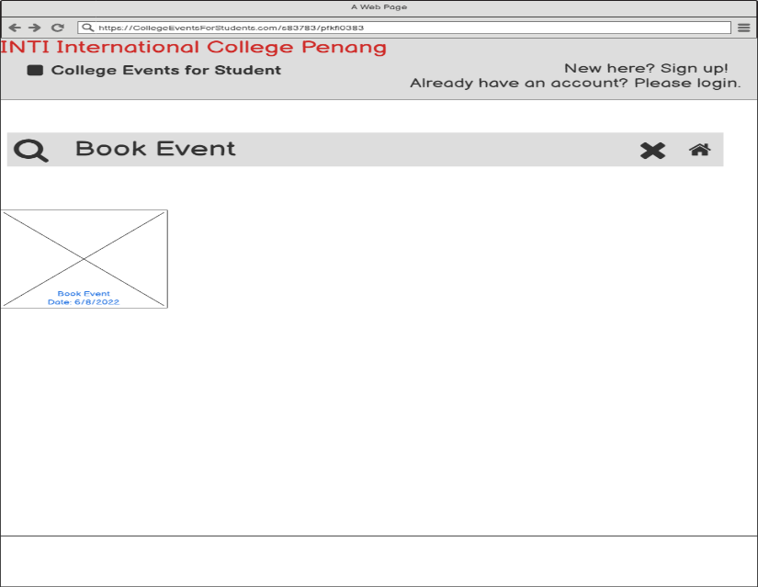

**Event Searching 2**

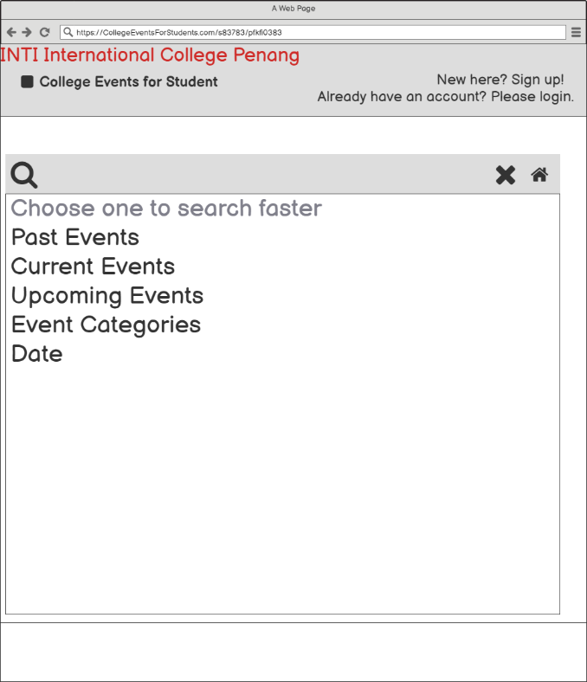

**Event Searching Past Results**

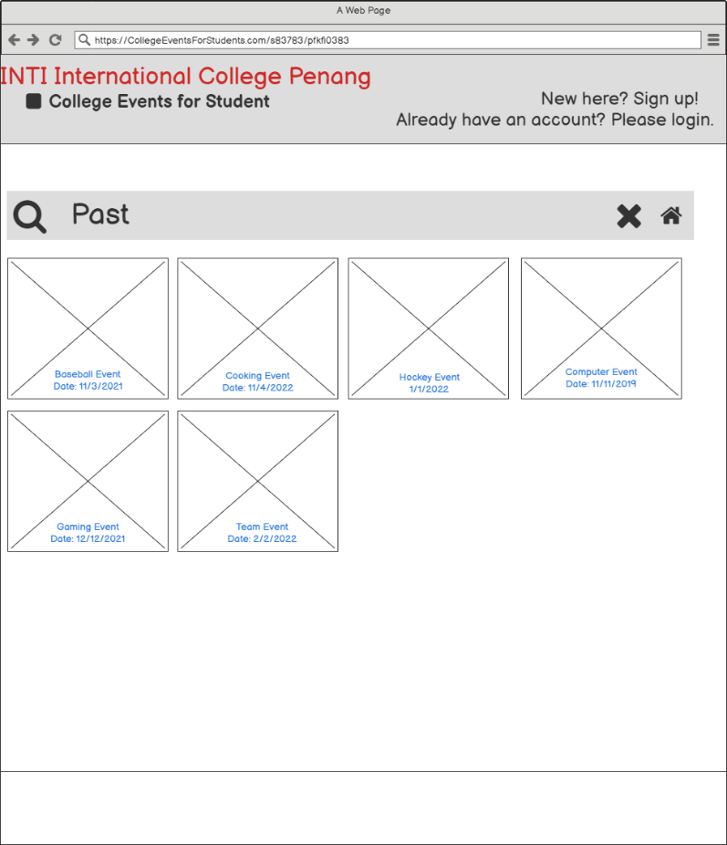

**Event Searching Current Results**

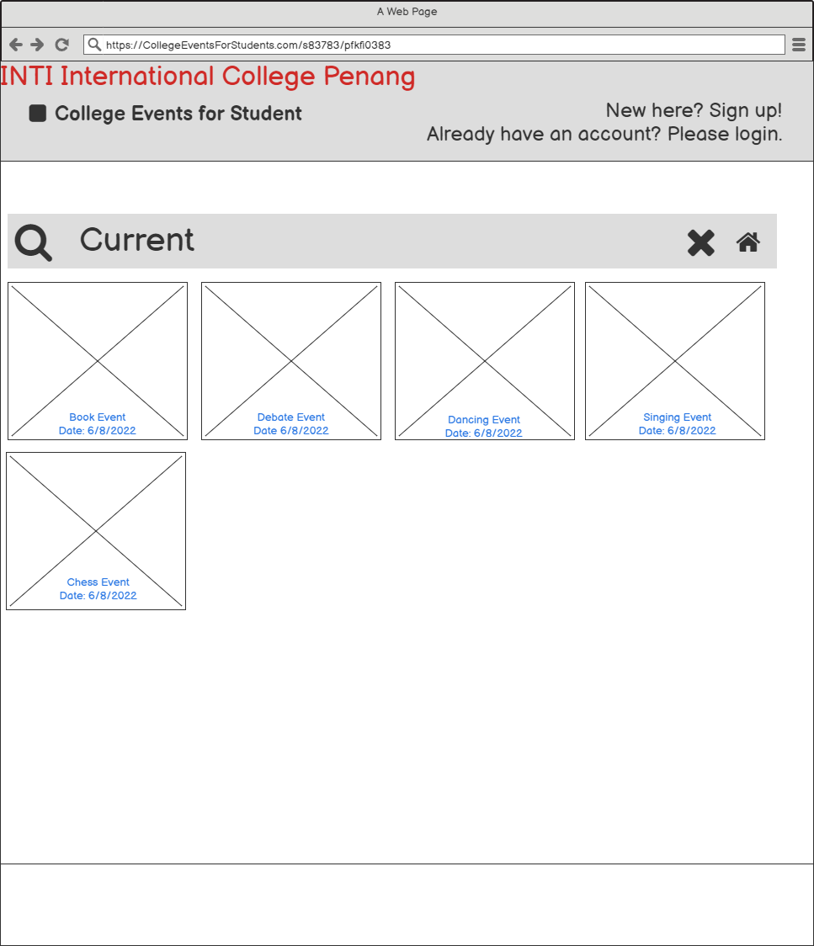

**Event Searching Upcoming Results**

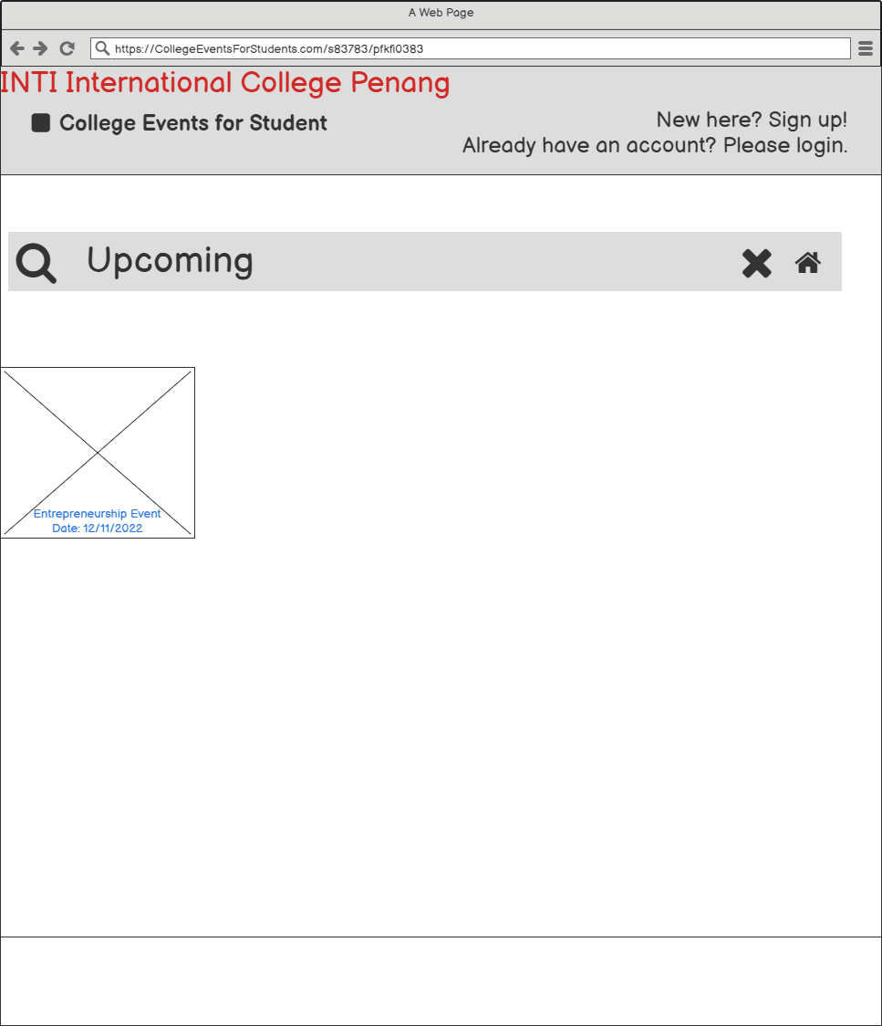

**Event Categories**

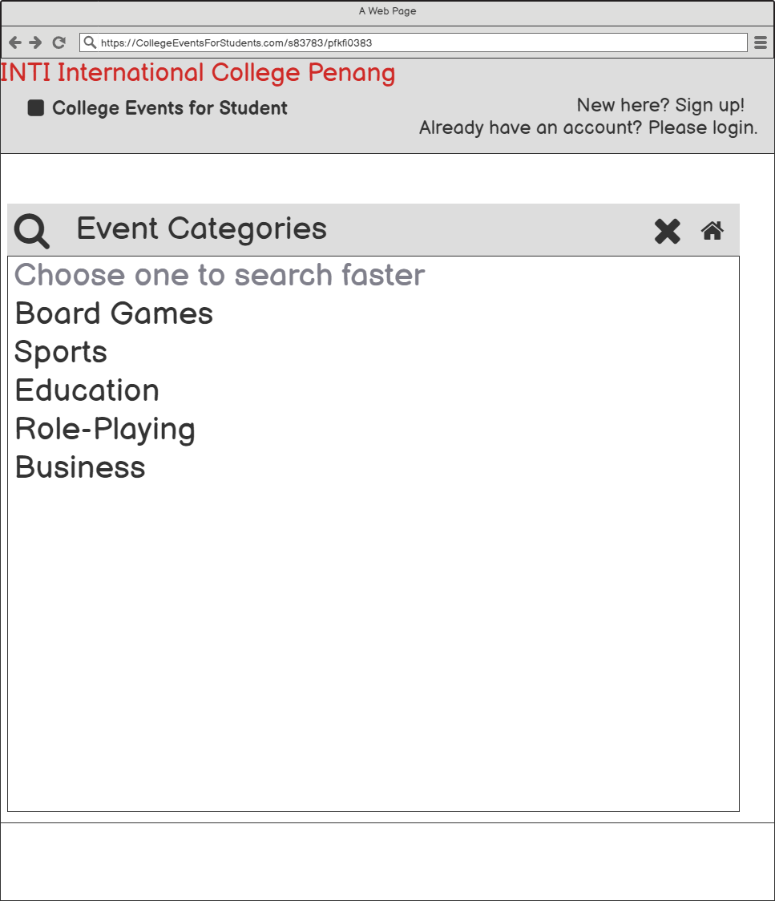

**Event Categories Category Results**

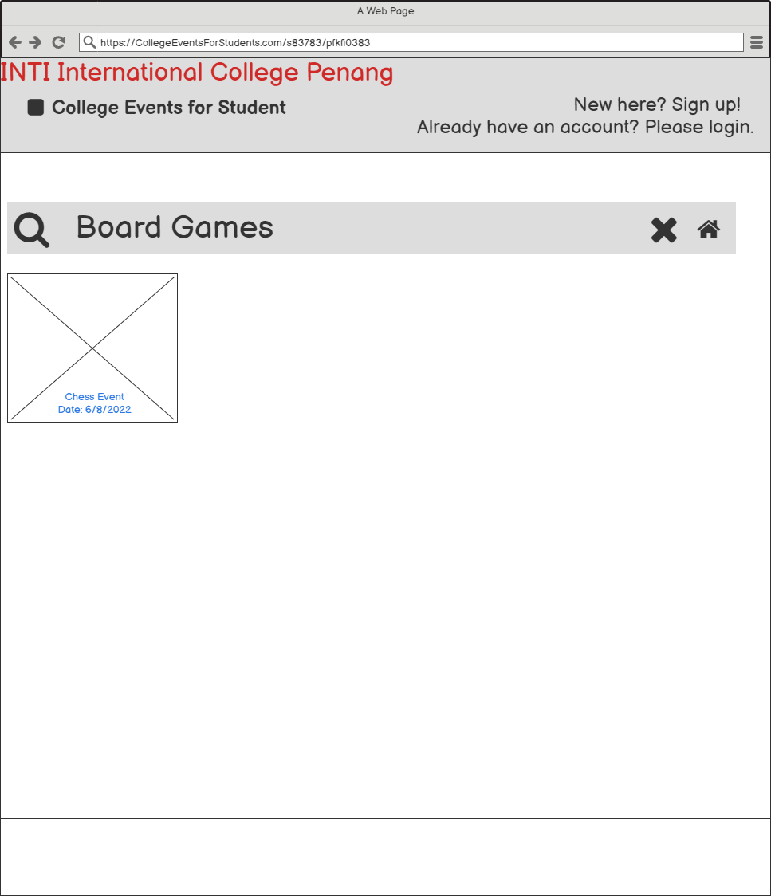

**Event Searching Date**

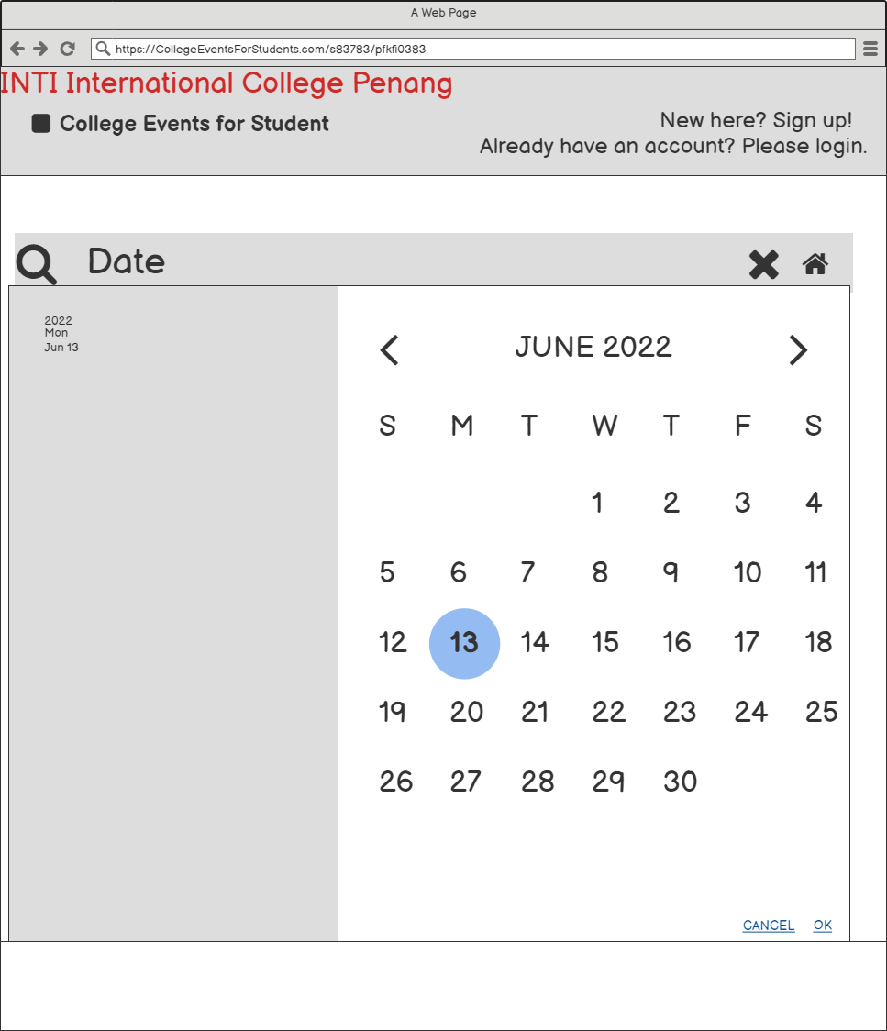

**Selected Date Results**

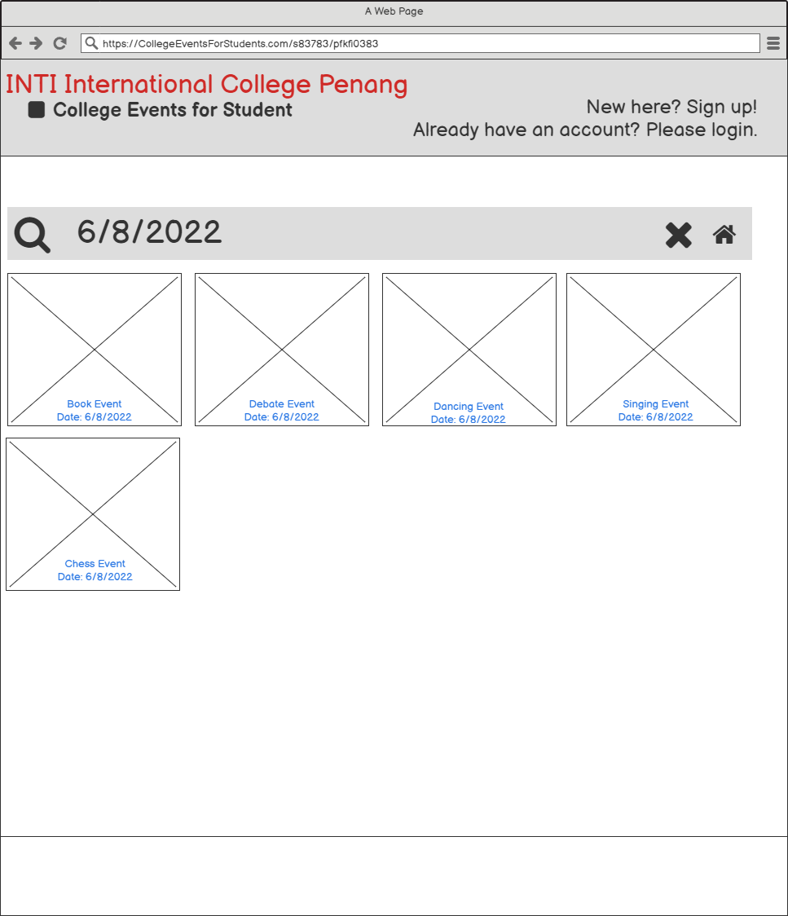

**Event Searching (Already Login)**

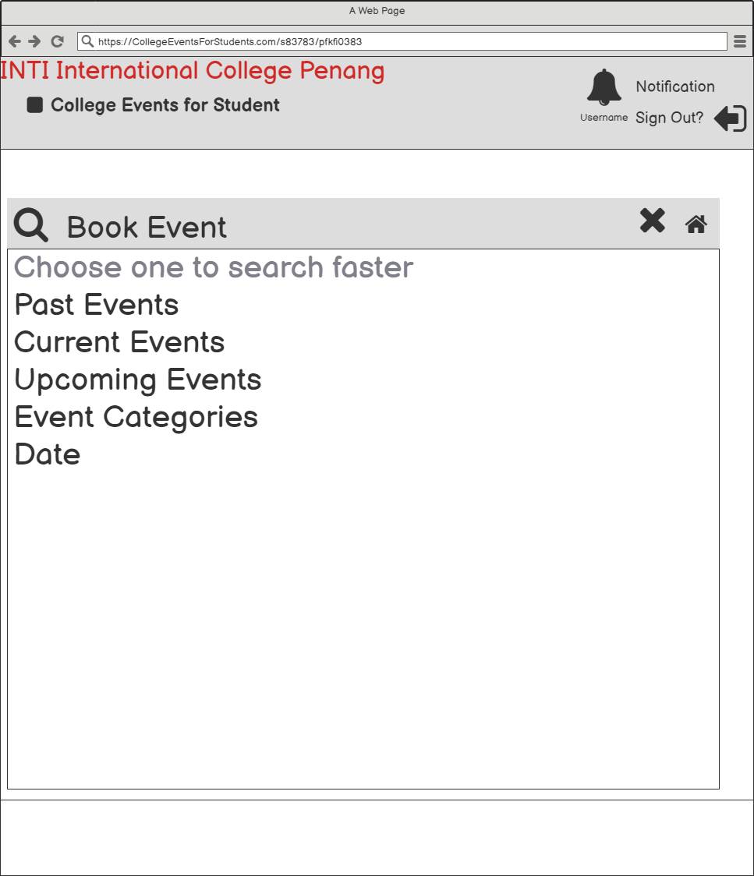

**Event Searching Results (Already Login)**

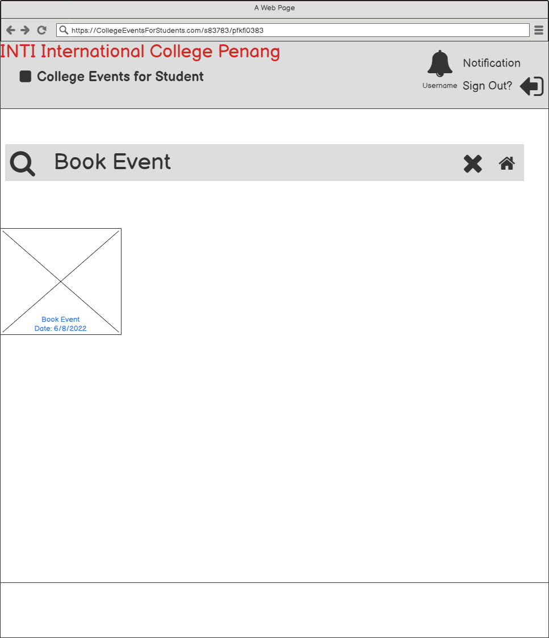

**Event Searching 2 (Already Login)**

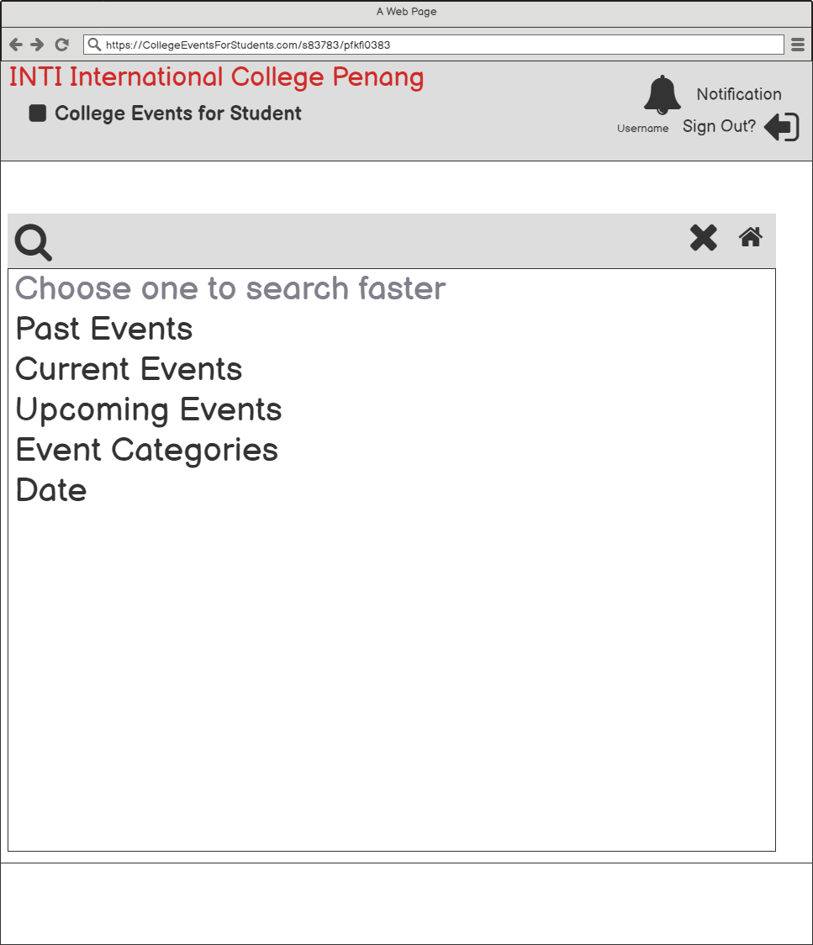

**Event Searching Past Results (Already Login)**

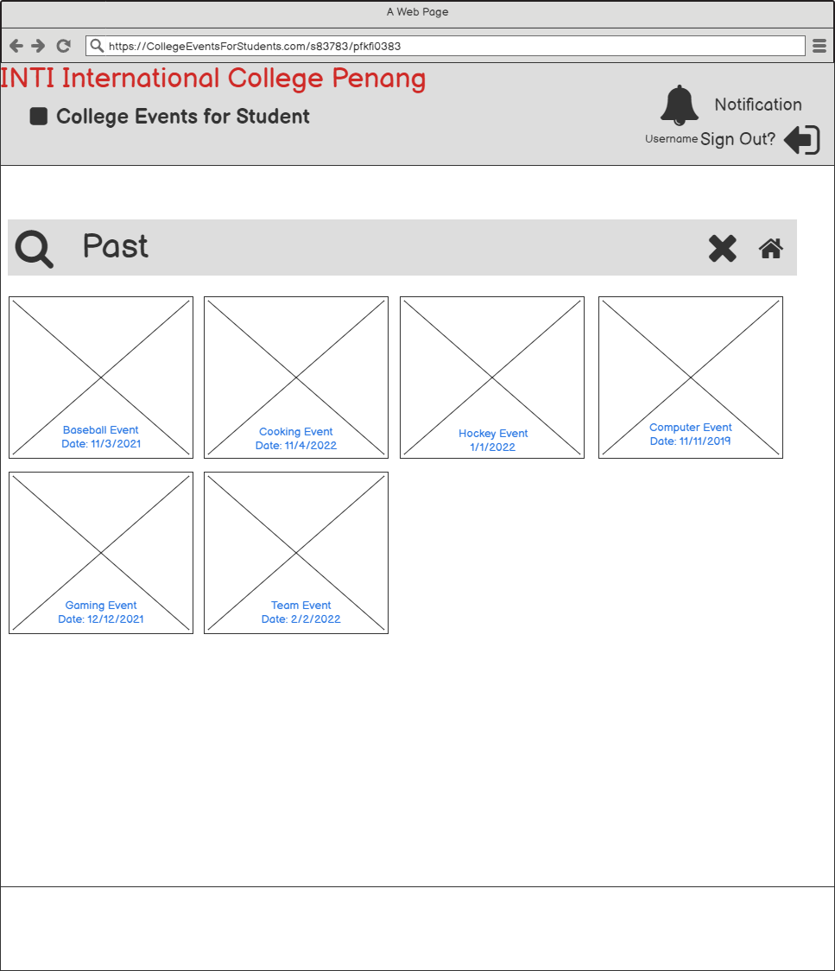

**Event Searching Current Results (Already Login)**

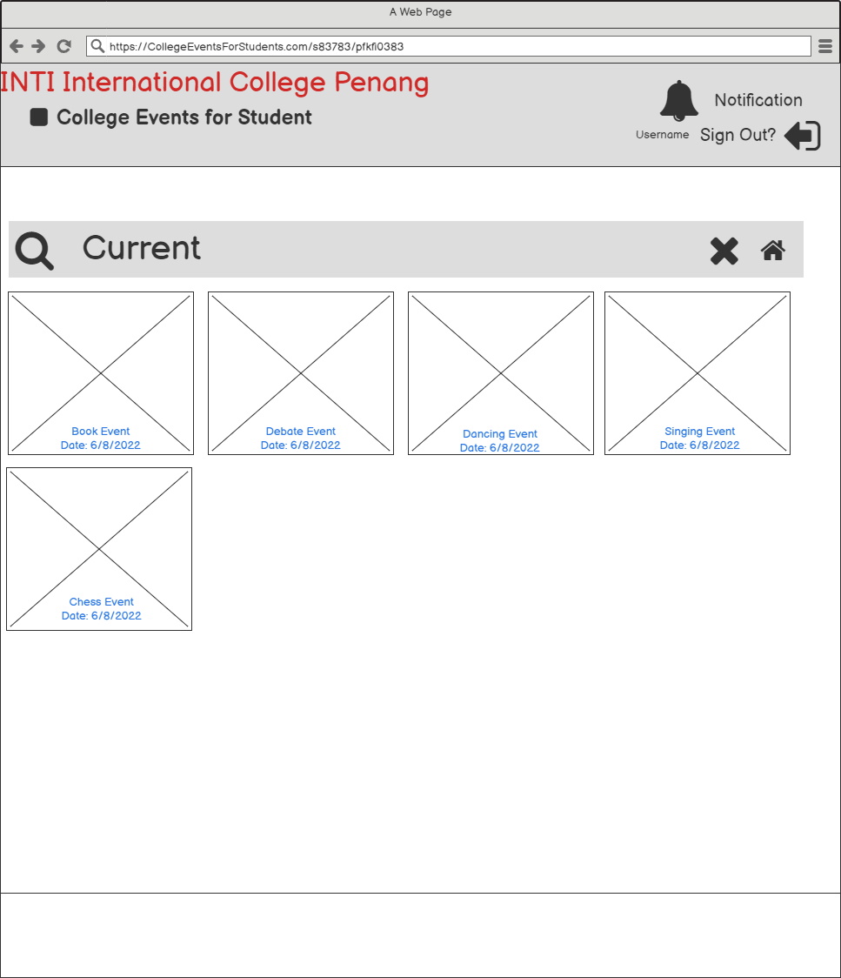

**Event Searching Upcoming Results (Already Login)**

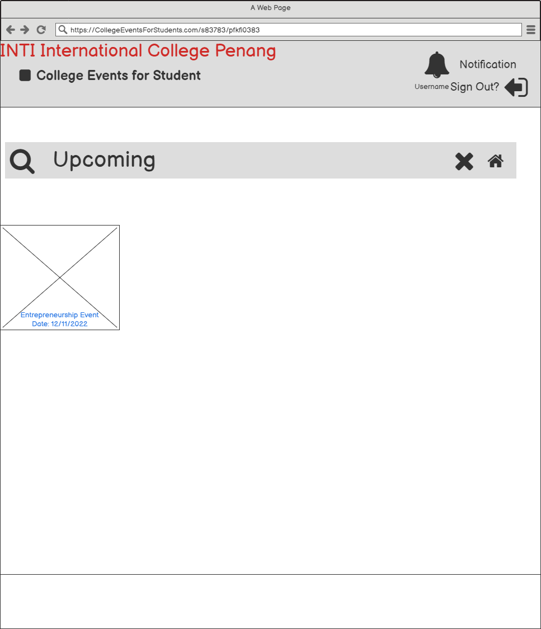

**Event Searching Categories (Already Login)**

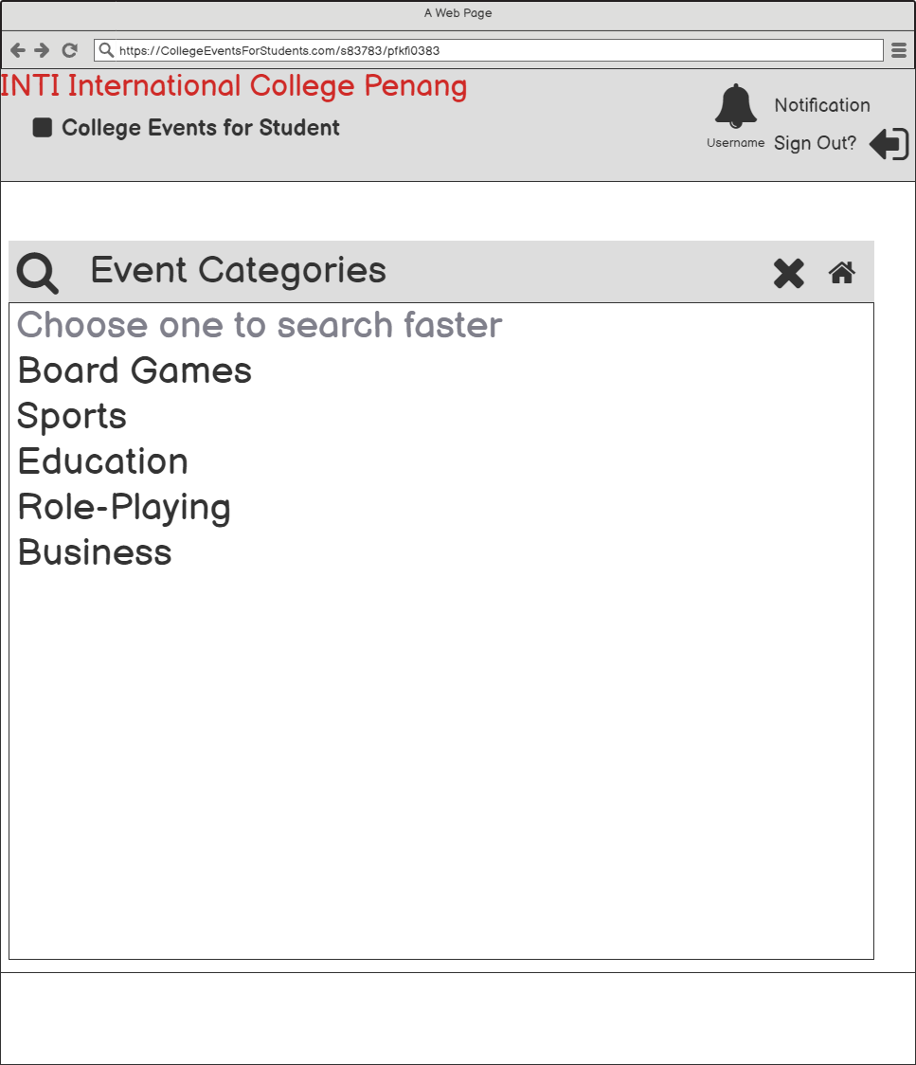

**Event Categories Category Results (Already Login)**

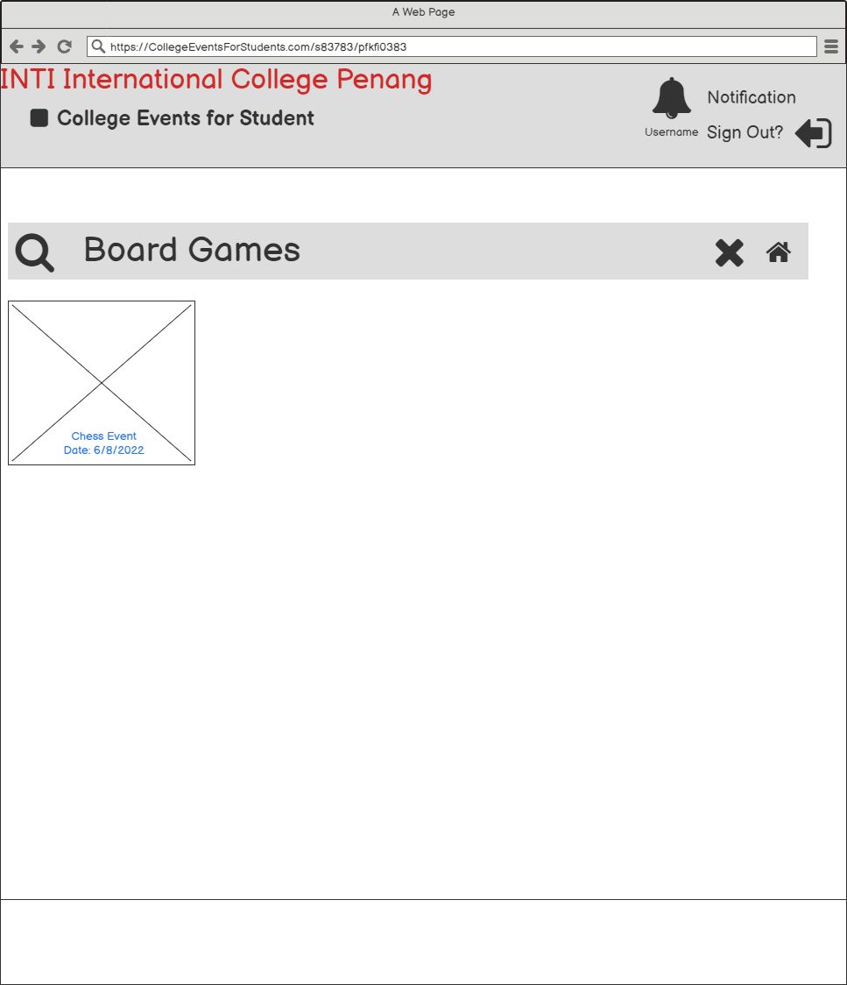

**Event Searching Date (Already Login)**

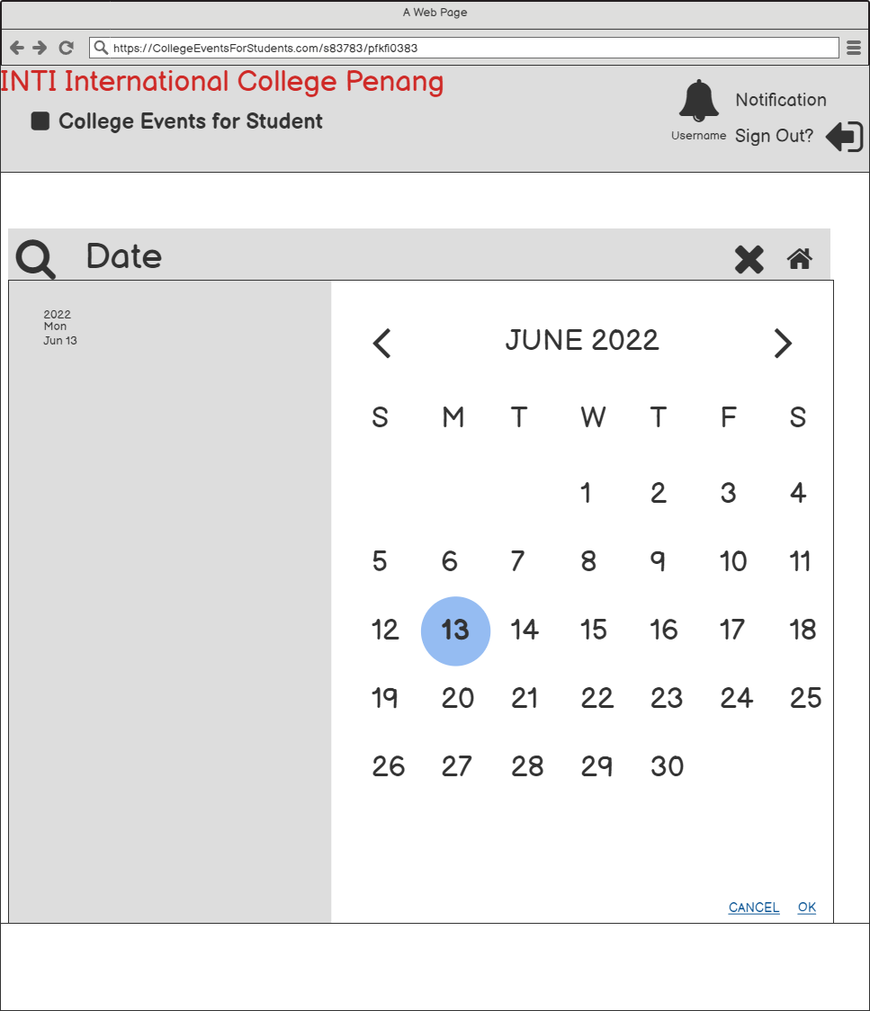

**Selected Date Results (Already Login)**

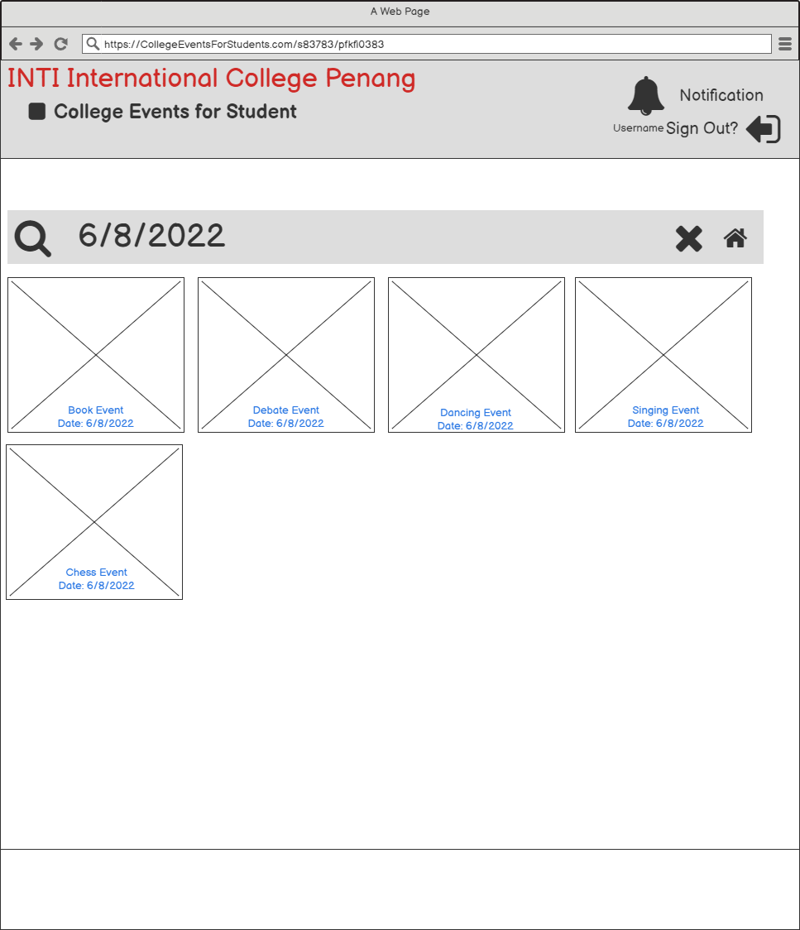

1. **Registration**

It asks a user to input their details and submit them. It signs up and confirms users for a particular event. It is similar to logging in as it creates protection for users.

When a user confirms the event, they fill out the registration form. After that, there is a popup message to check inside the notification bell. Once a user goes to the event homepage, the Book Event has the word “Participated” on top. The event will tell that the user has already participated once clicking the event.

Registration is less time-consuming and saves paper-based resources for the organiser. It also saves users time as they feel comfortable doing on the website.

**Book Event (Already Login)**

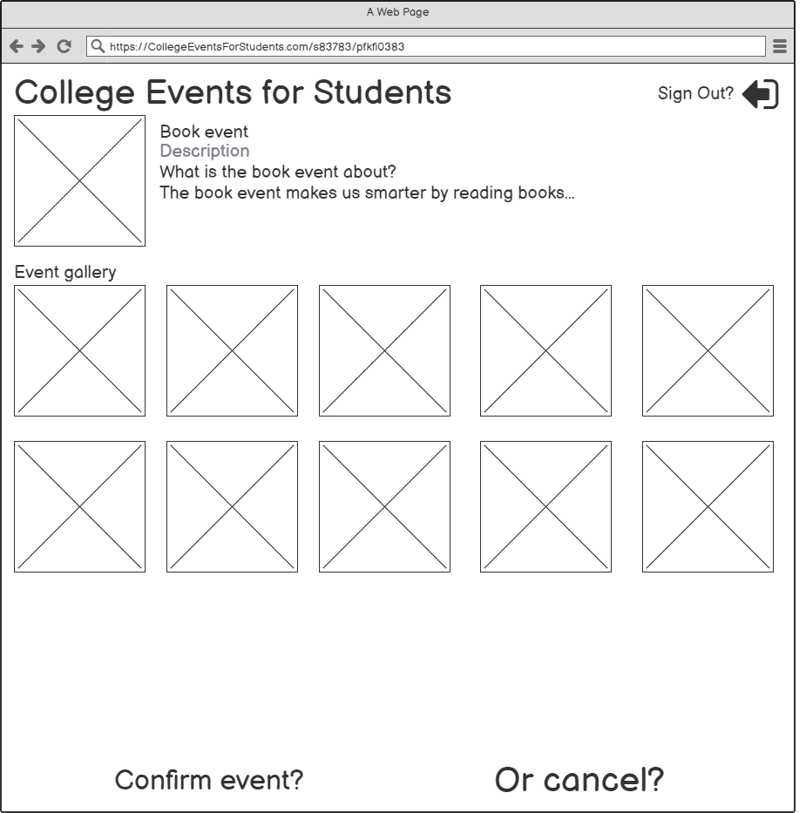

**Registration Form**

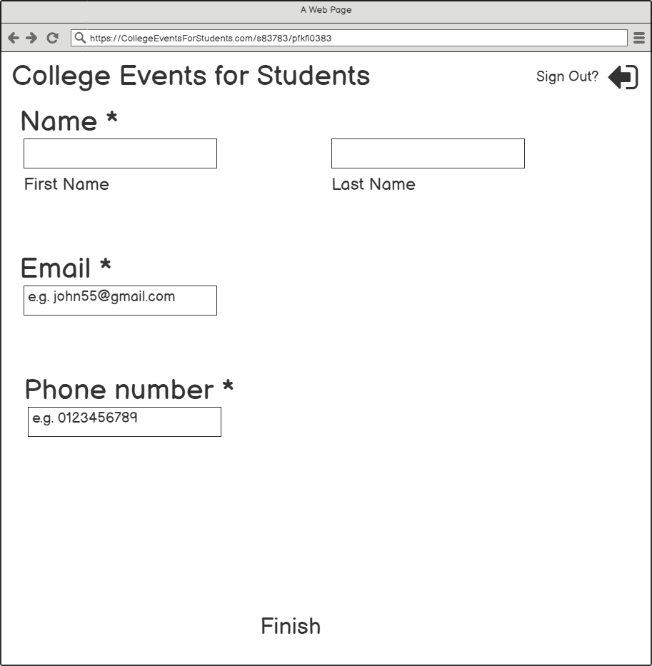

**Popup Message**

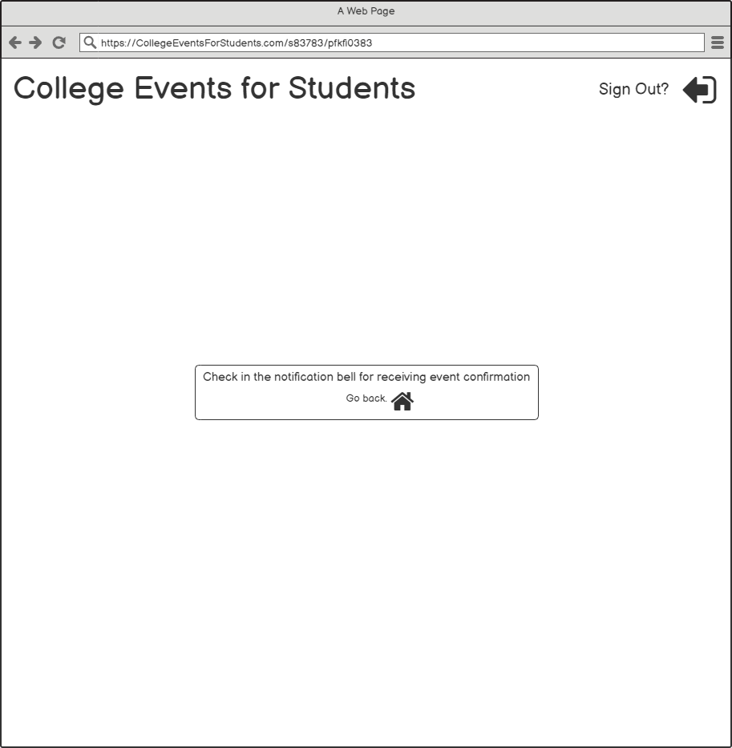

**Event Homepage With Event Confirmation Notification**

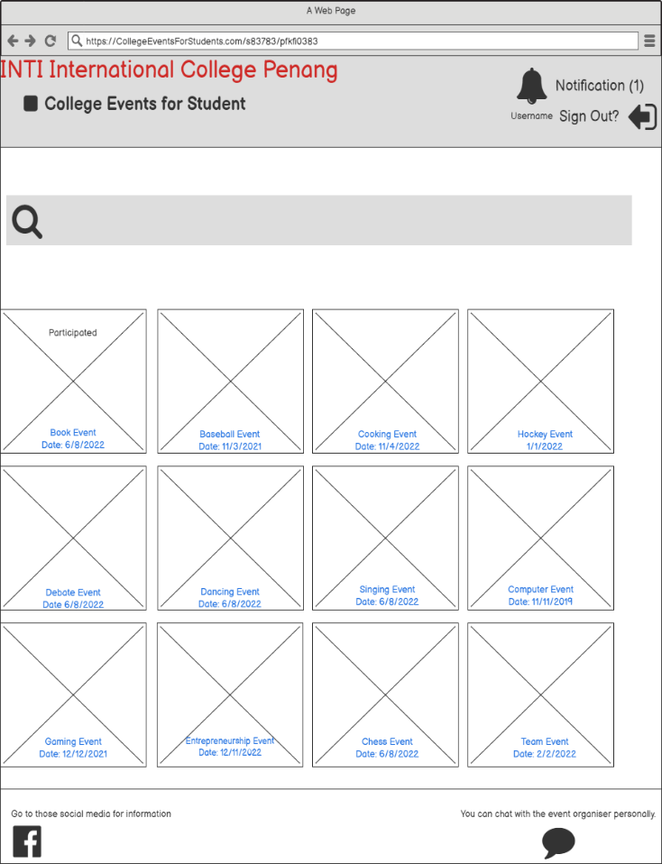

**Show A Popup Message If Already Participated**

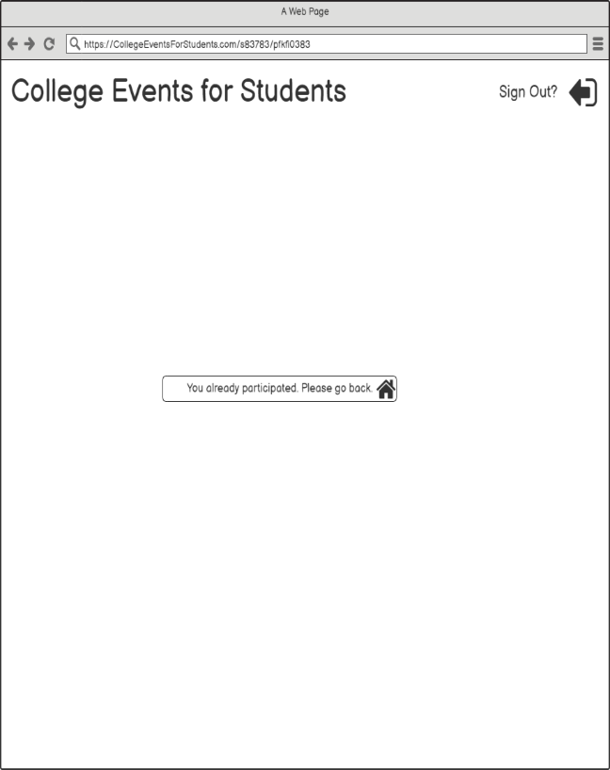

**Inbox With Event Confirmation Notification**

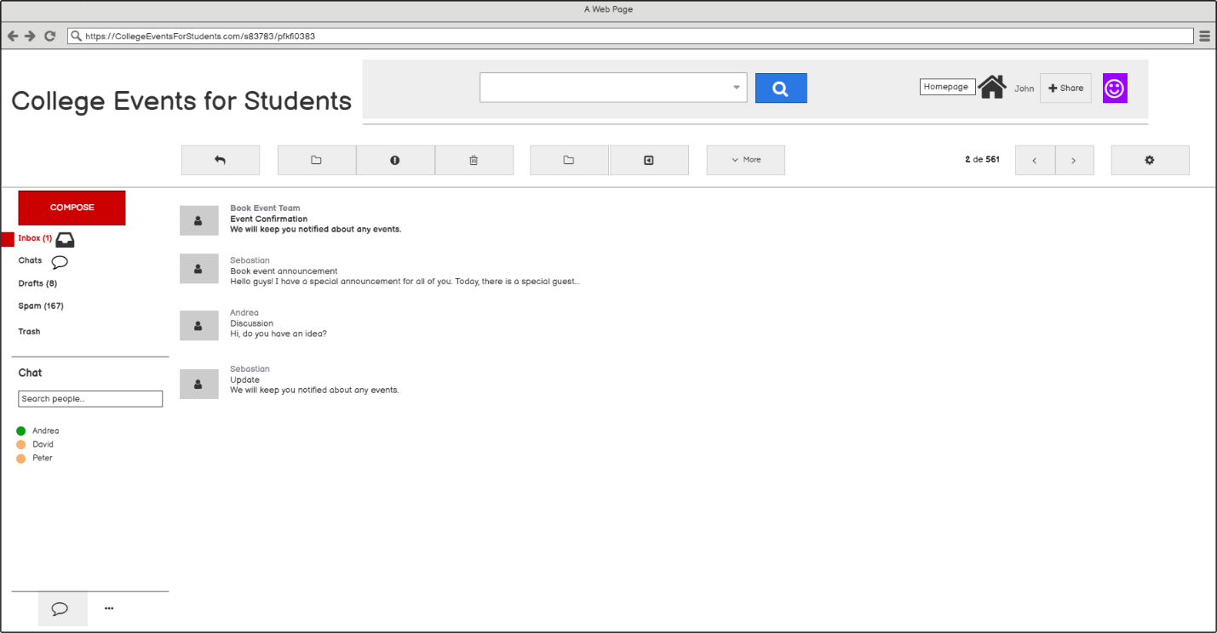

**Checking Event Confirmation**

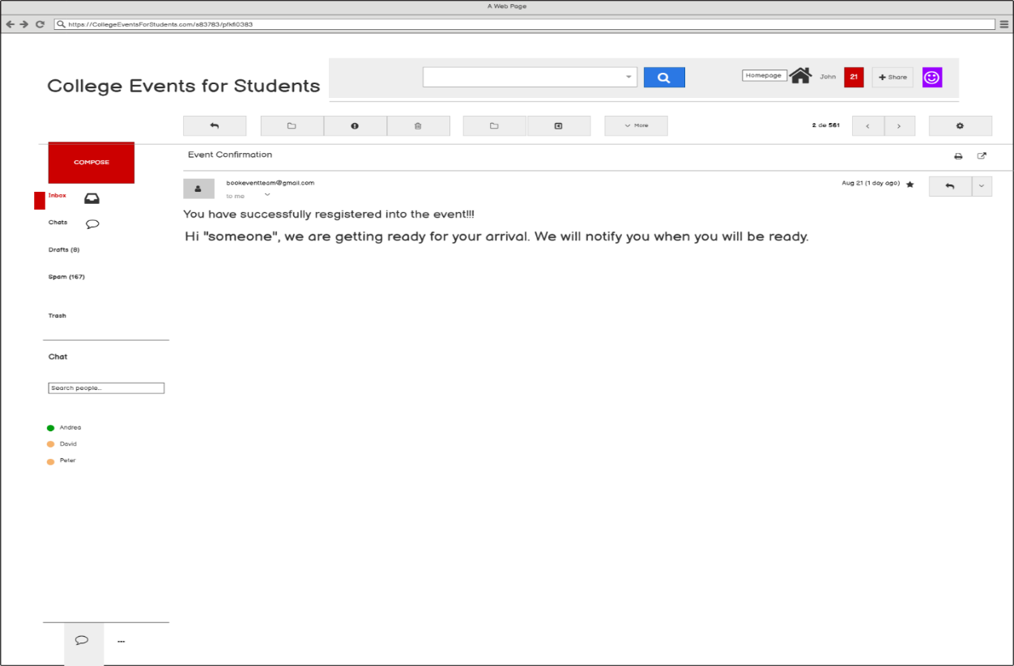

**Back To Inbox**

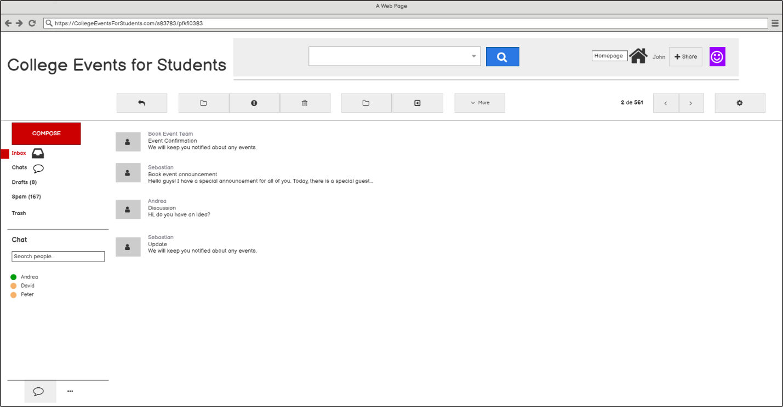

**Finish**

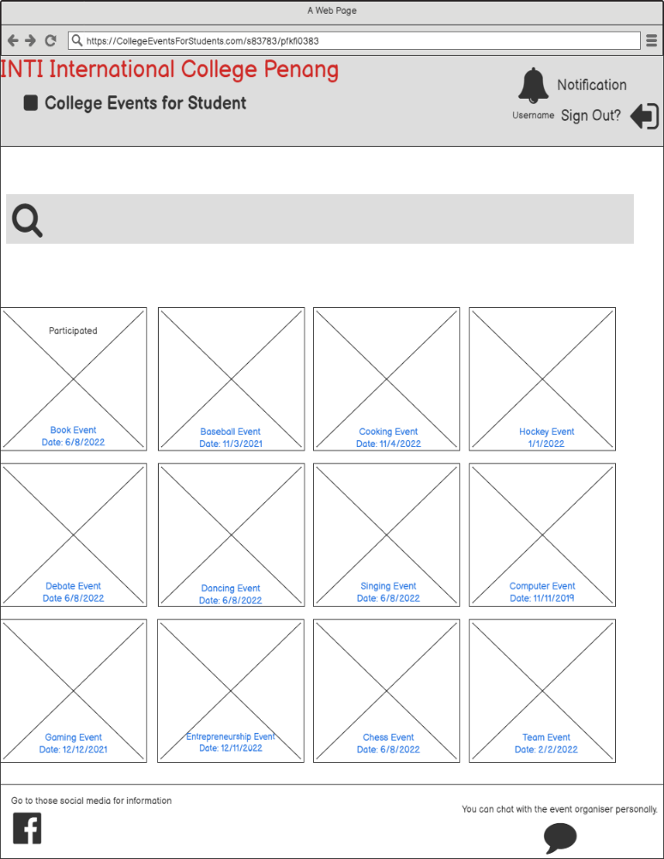

**Show A Popup Message If Already Participated 2**

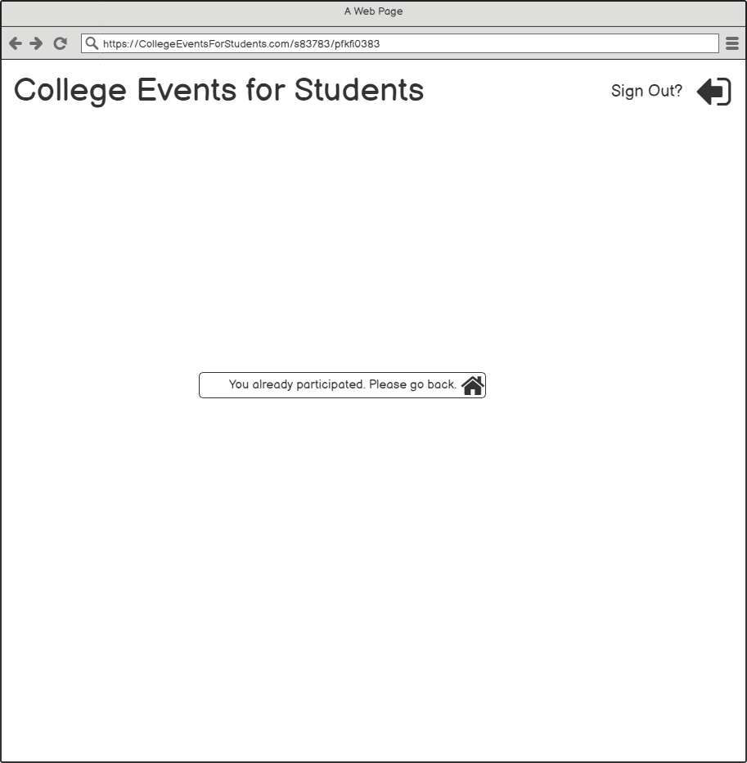

# Usability Testing Questions

The following are the Usability Testing Questions: -.

1. How to search the “College events for students’ website”?
2. How to log in?
3. If you forget your password, where do you find the link that helps you to create the new one?
4. Please re-type the password after typing a password when signing up.
5. How do you create a new account if you cannot log in?
6. Where would it take you to search the events?
7. Which category do you want to categorize in the search box to search for Book Event faster?
8. How do you remove the desired result like Book Event?
9. How to return to the event homepage?
10. Where do you get more information about the event using social media like Facebook?
11. How to come back to the event homepage from Facebook?
12. How to talk to a specific person like an event organizer privately?
13. How do you register to join the event?
14. How do you get back to the homepage after seeing the pop-up message?
15. How to check that you have already participated in the event?
16. How to find out that you have a new notification after finishing registration?
17. How to get back to the homepage if you receive new notifications?
18. What do you do if you want to log out to get out of the website?

**All the pages**

1. **Search Using Google**

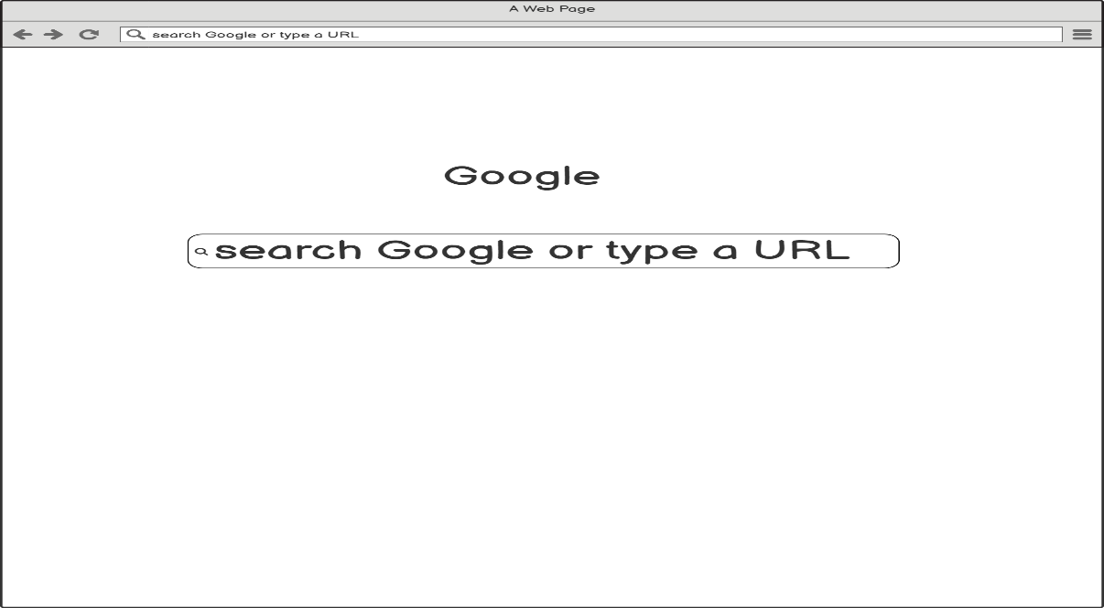

1. **Searching**

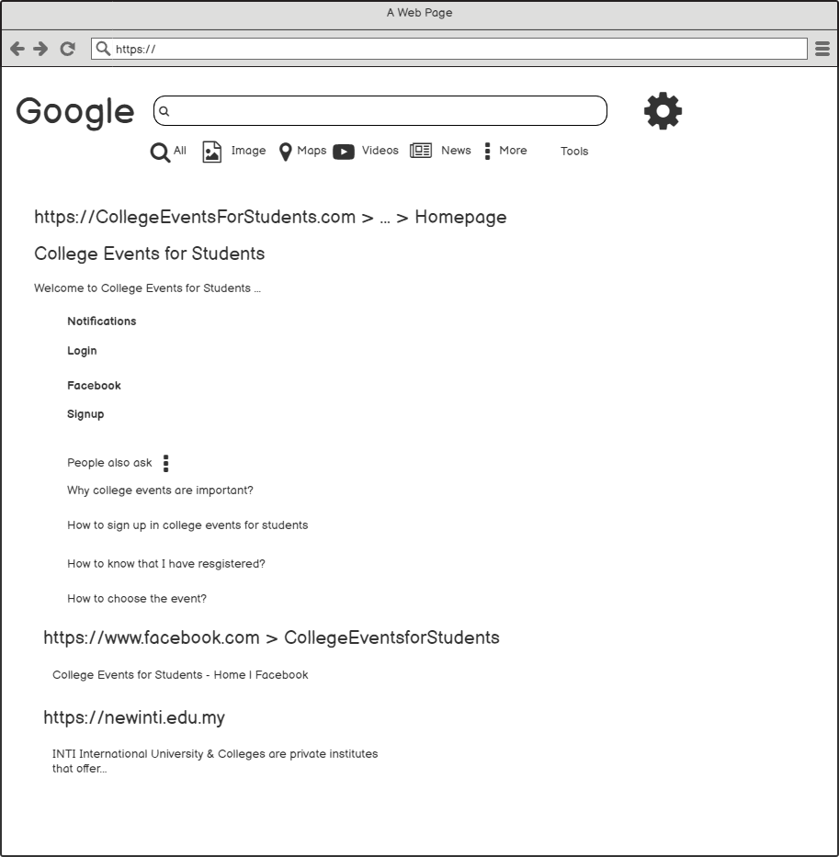

1. **Cookies (Before Login)**

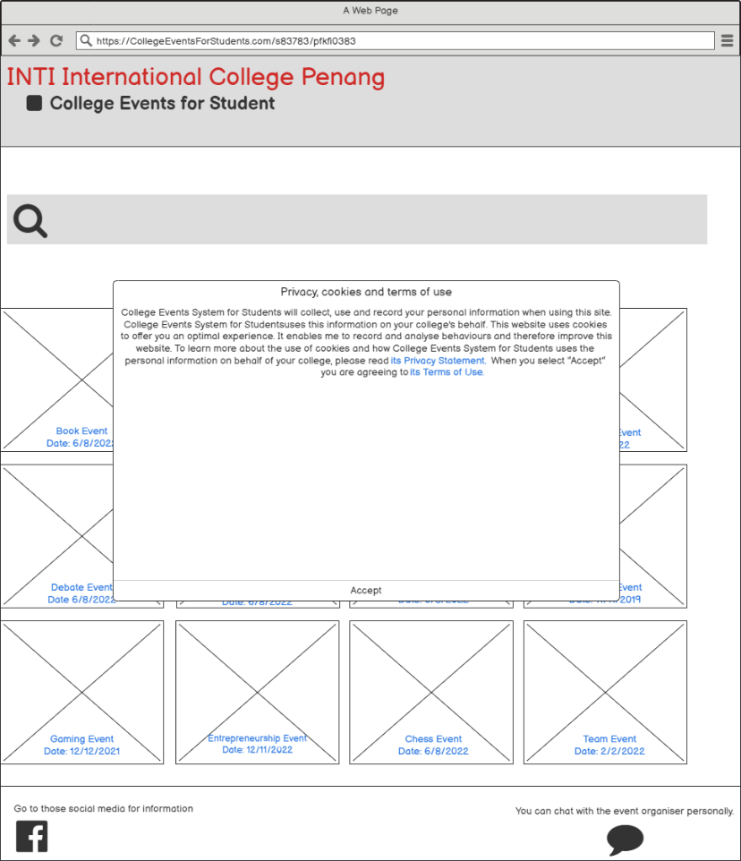

1. **Privacy Statement (Before Login)**

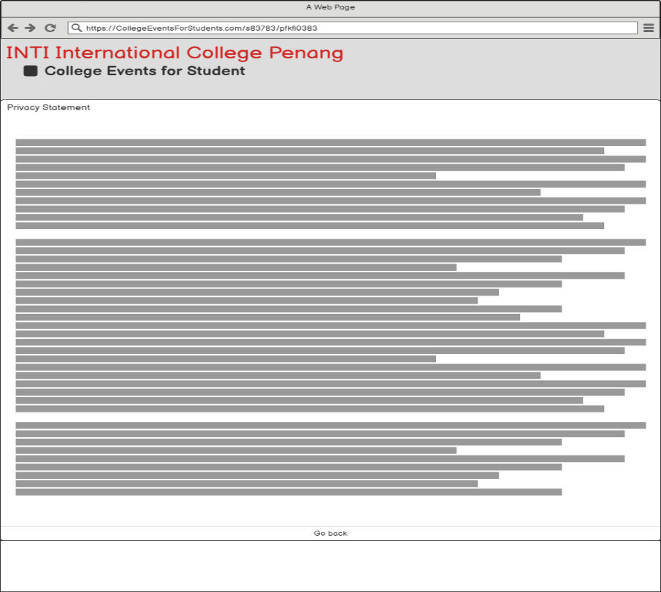

1. **Terms of Use (Before Login)**

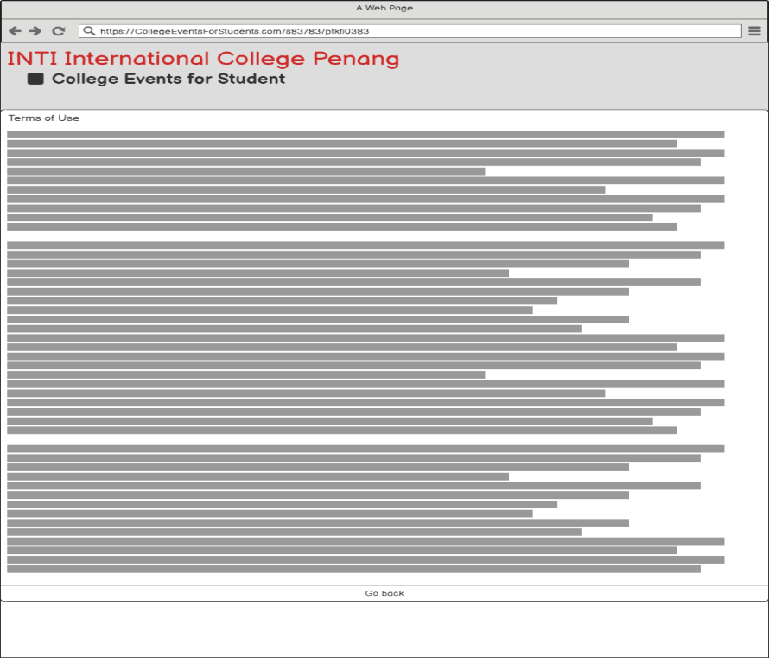

1. **Event Homepage (Before Login)**

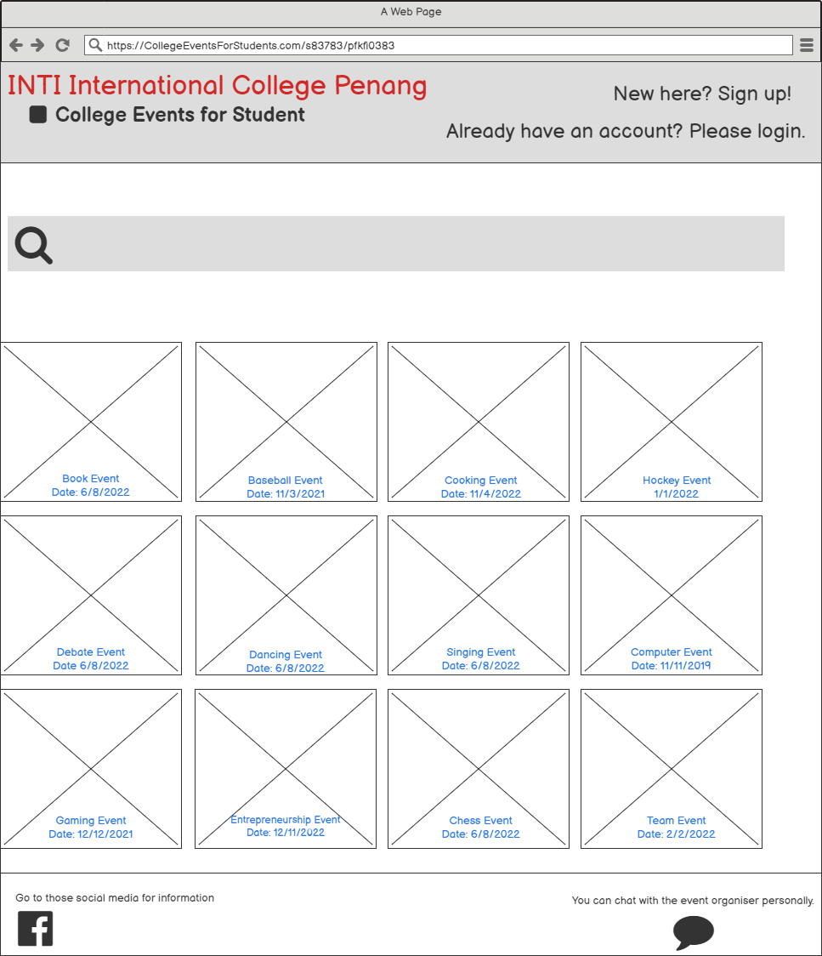

1. **Event Searching**

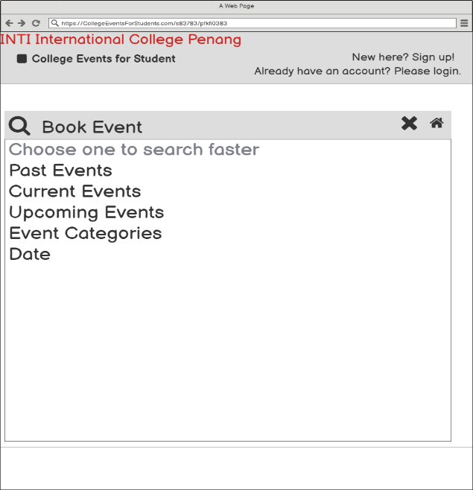

1. **Event Searching Results**

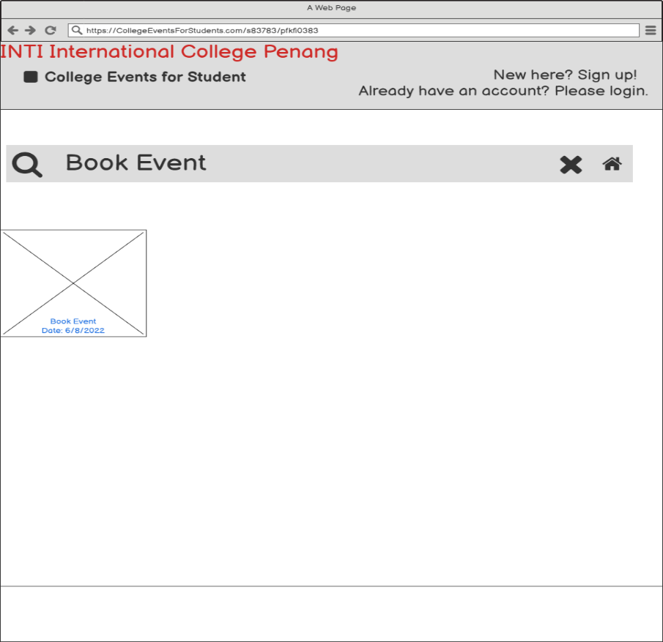

1. **Event Searching 2**

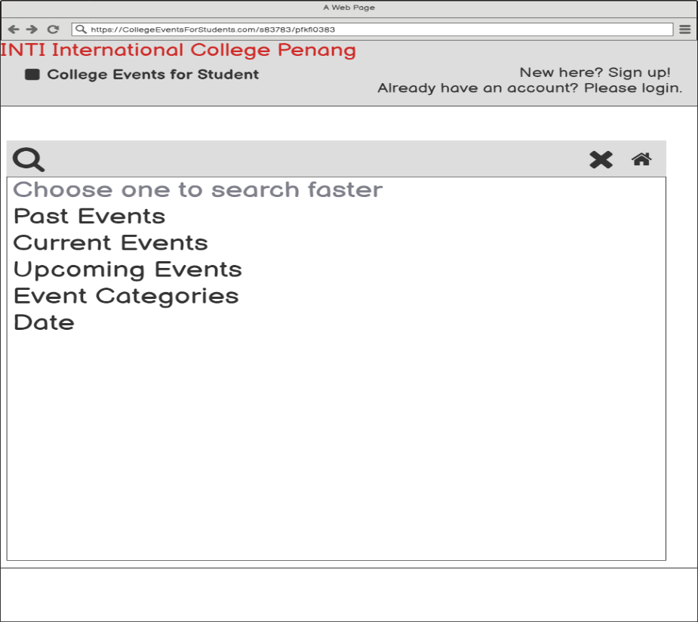

1. **Event Searching Past Results**

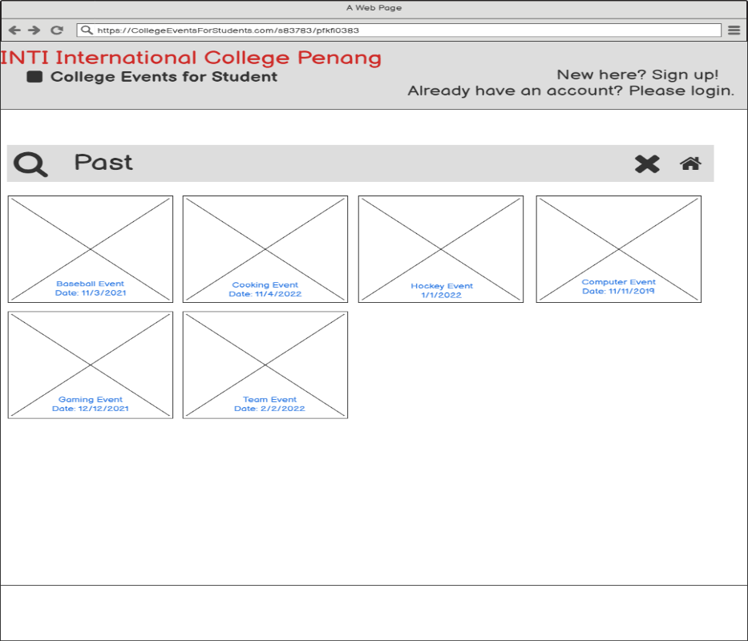

1. **Event Searching Current Results**

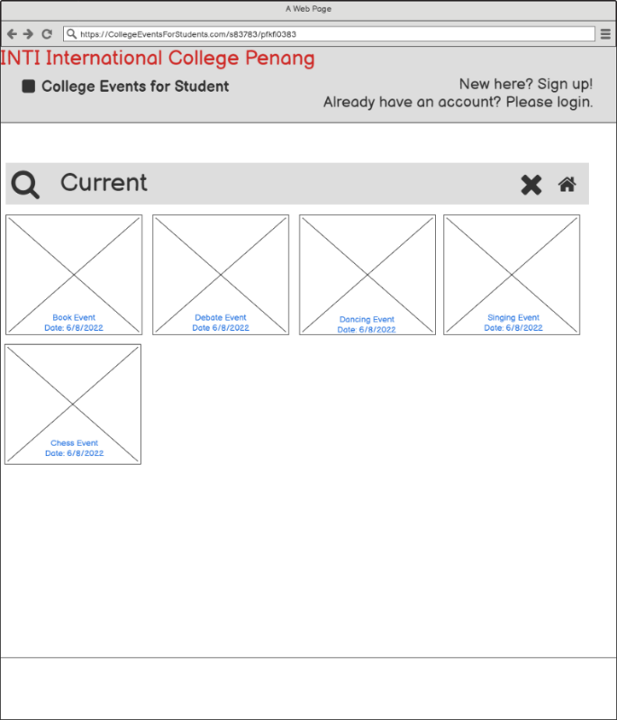

1. **Event Searching Upcoming Results**

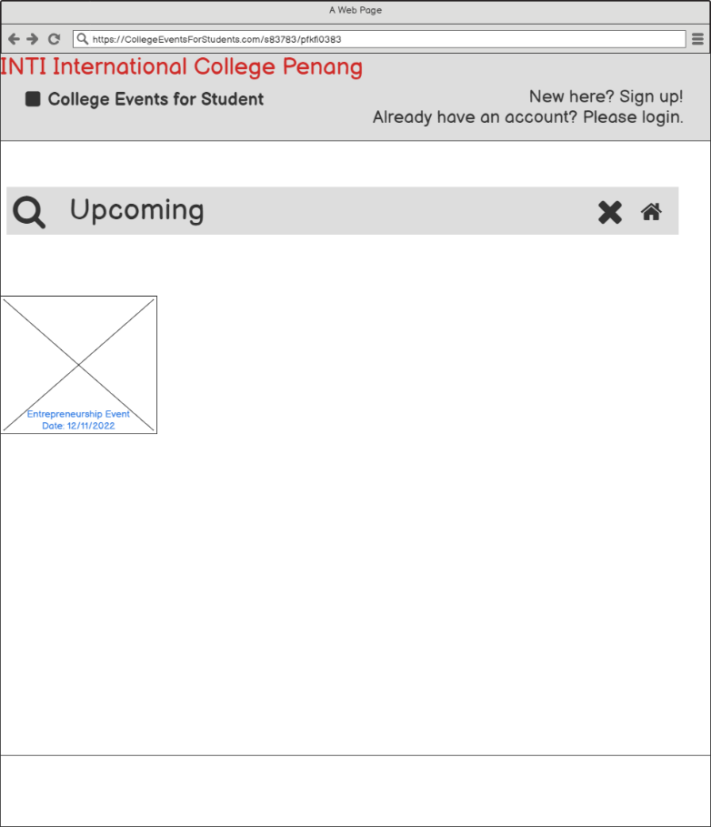

1. **Event Categories**

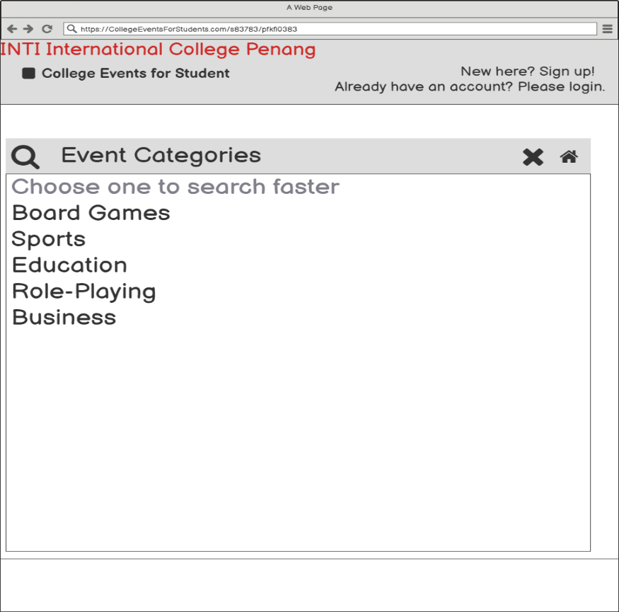

1. **Event Categories Category Results**

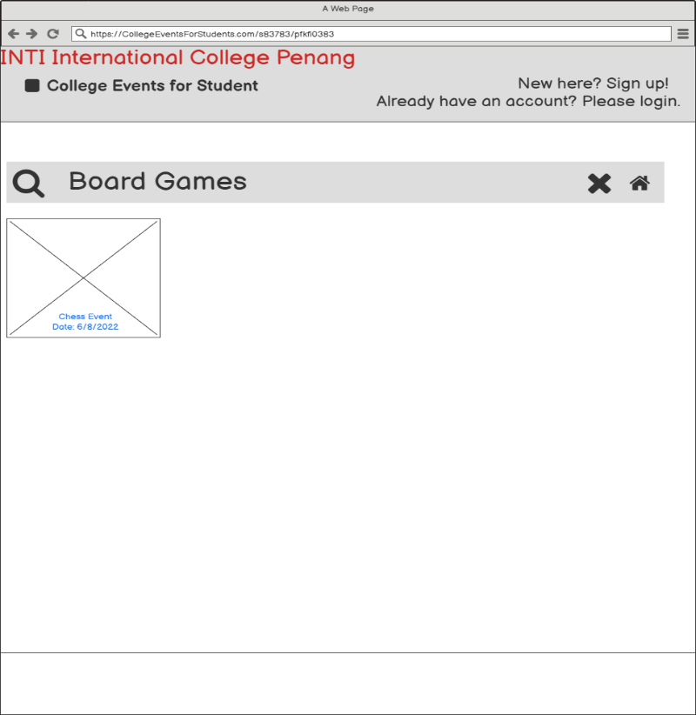

1. **Event Searching Date**

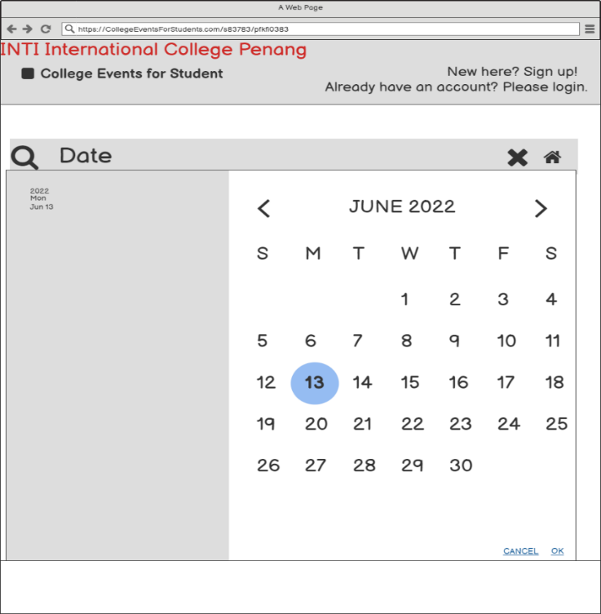

1. **Selected Date Results**

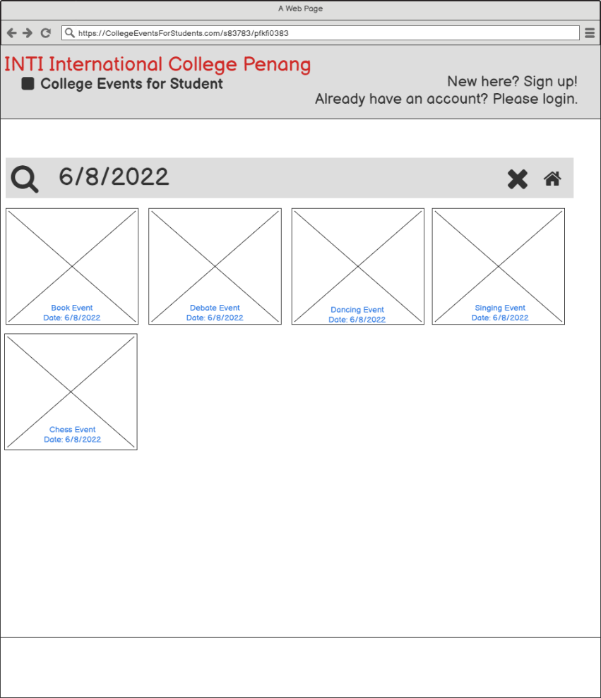

1. **Facebook**

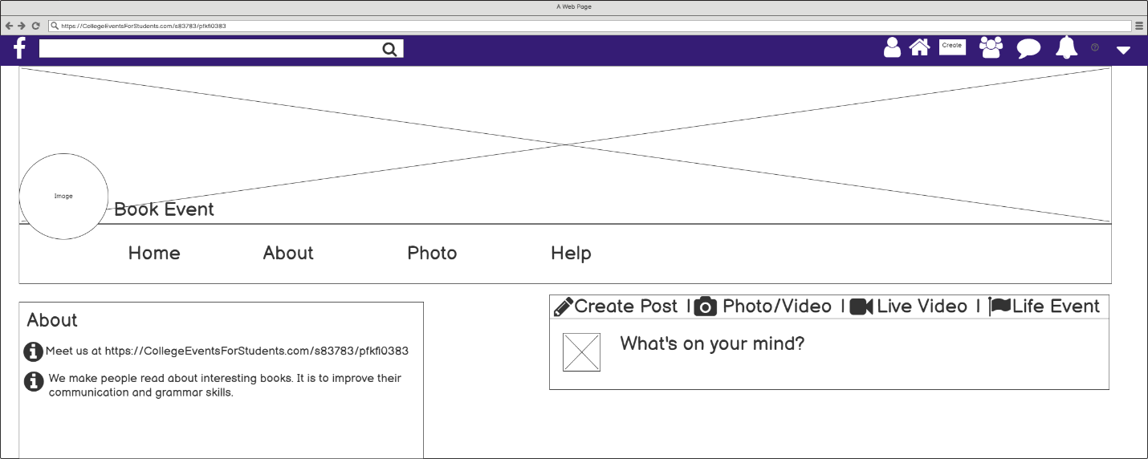

1. **Event Organiser Chat (Before Login)**

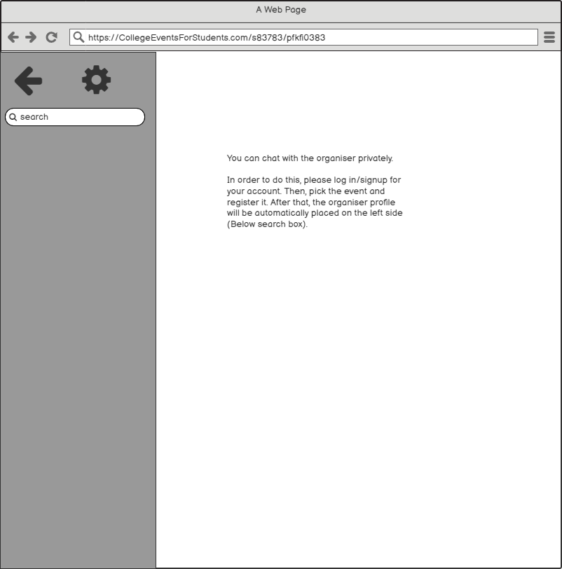

1. **Login Page**

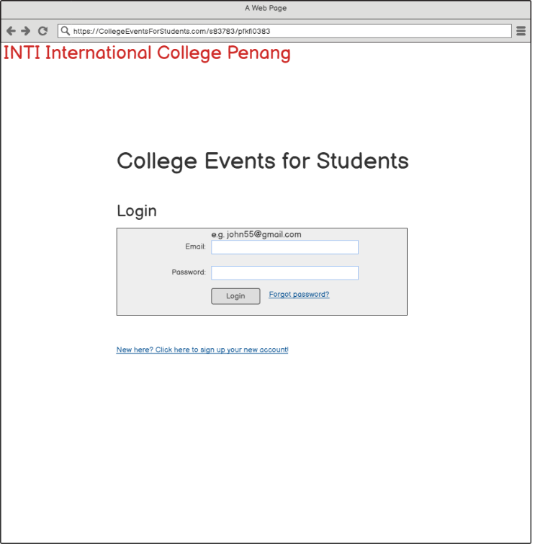

1. **Sign Up**

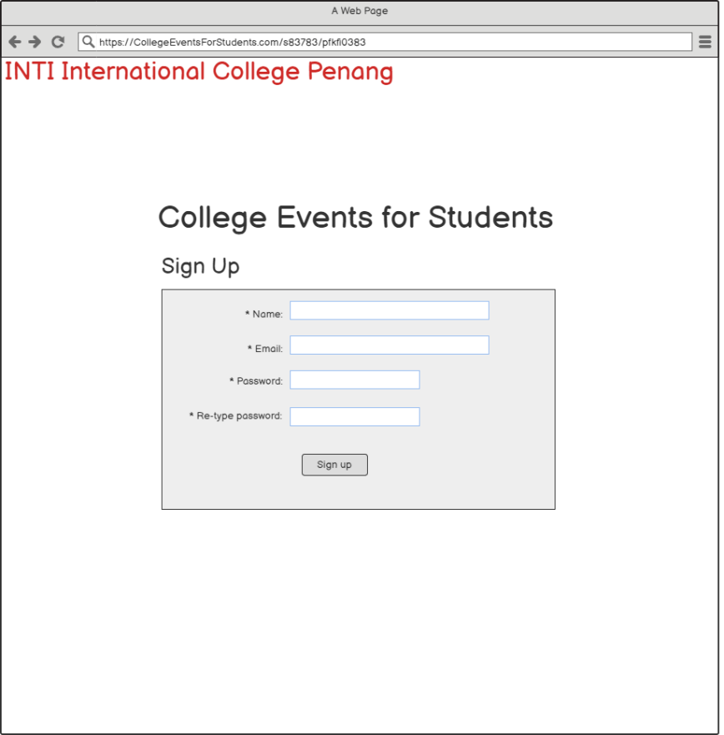

1. **Forget Password**

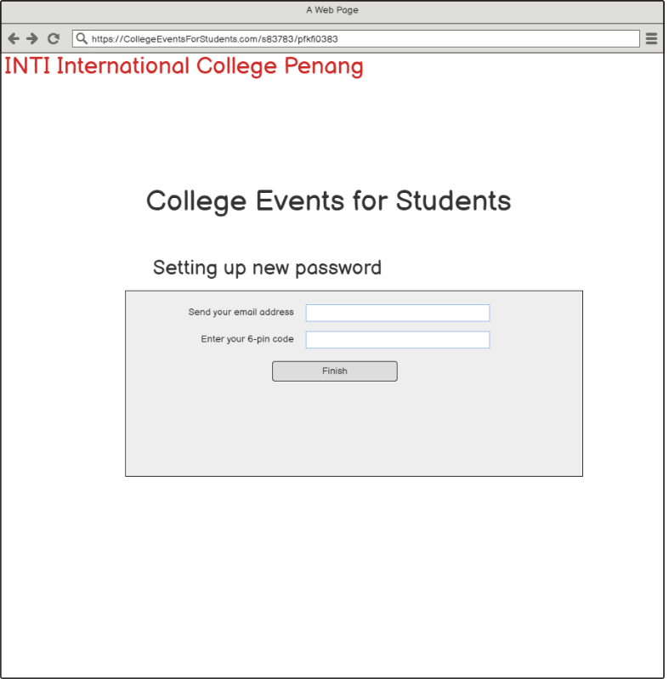

1. **Create Your New Password**

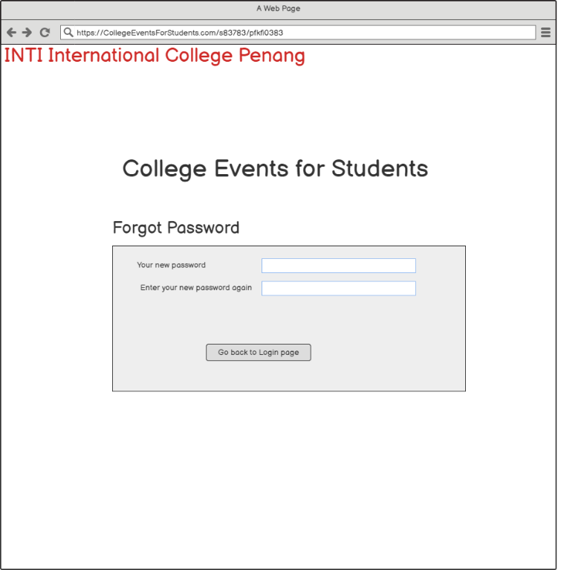

1. **Event Homepage**

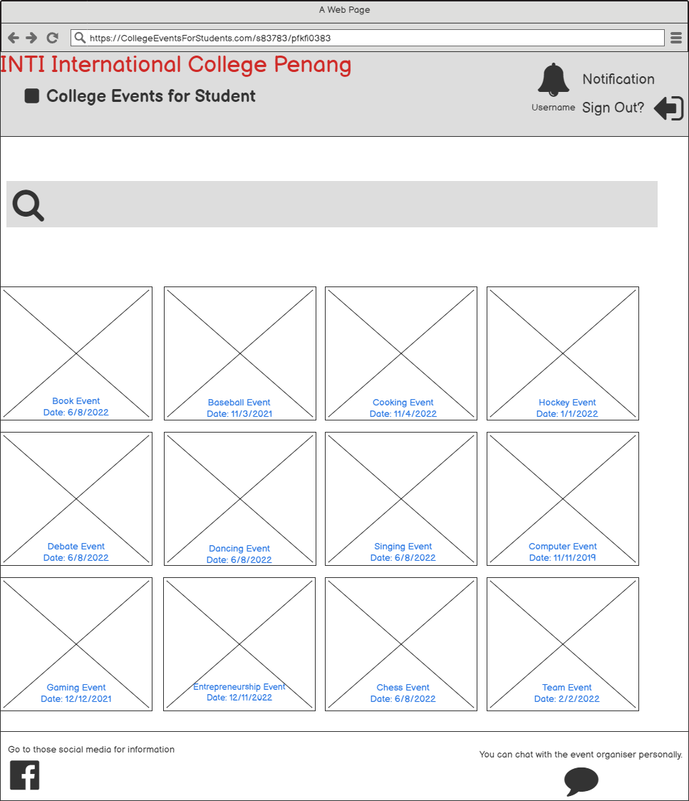

1. **Event Searching (Already Login)**

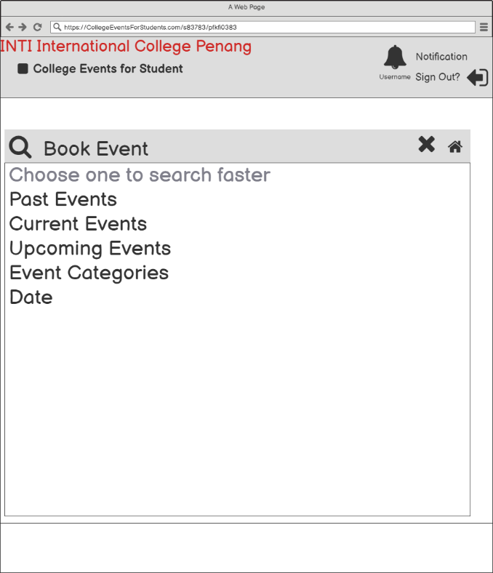

1. **Event Searching Results (Already Login)**

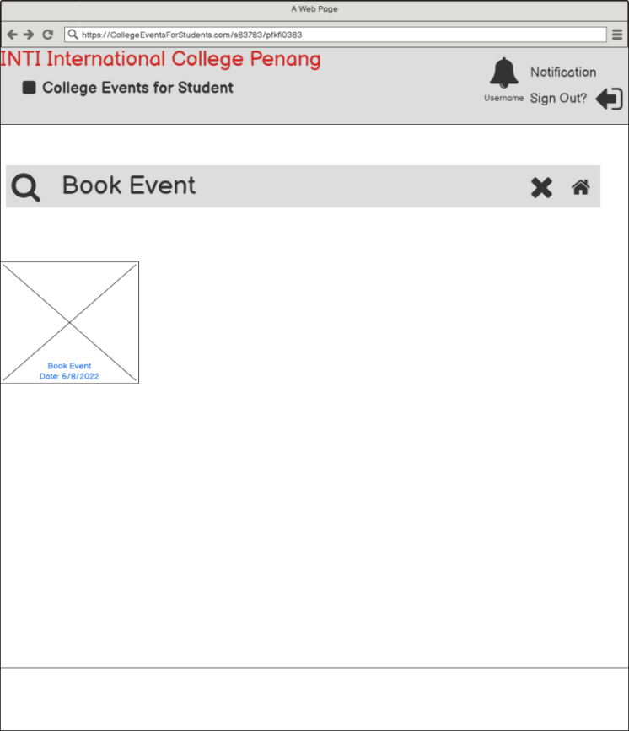

1. **Event Searching 2 (Already Login)**

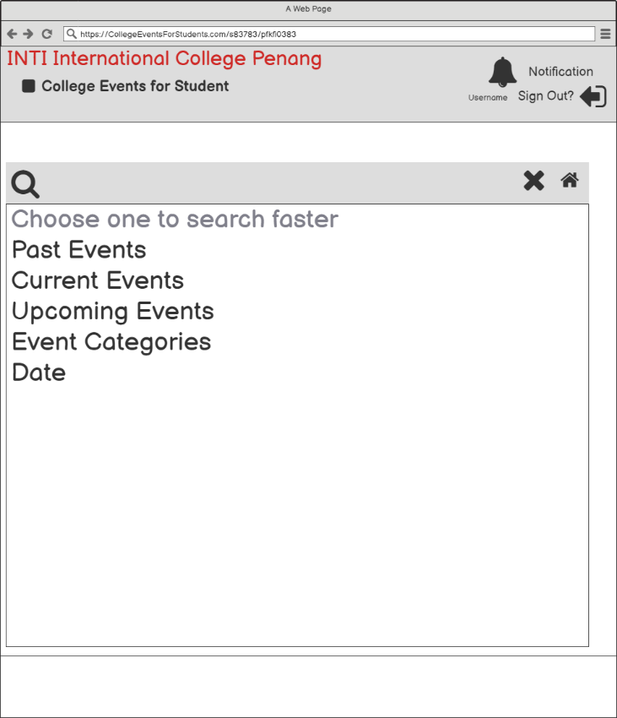

1. **Event Searching Past Results (Already Login)**

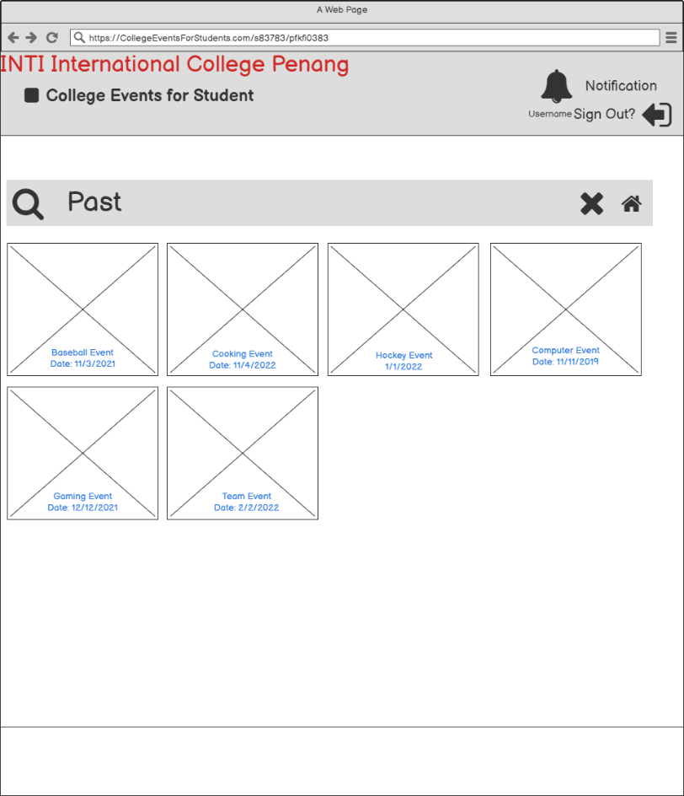

1. **Event Searching Current Results (Already Login)**

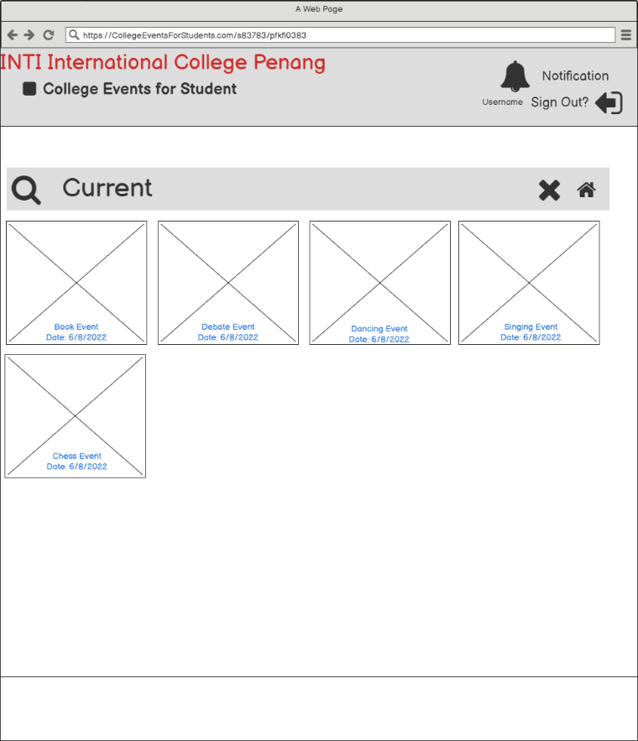

1. **Event Searching Upcoming Results (Already Login)**

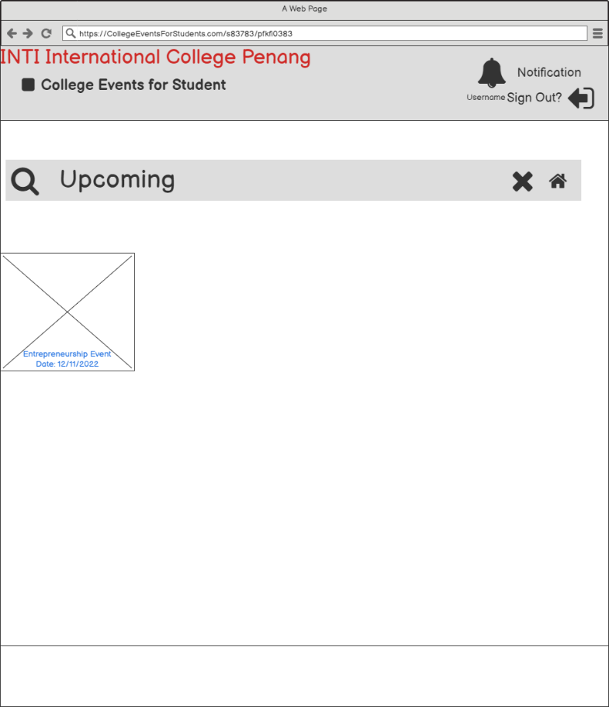

1. **Event Searching Categories (Already Login)**

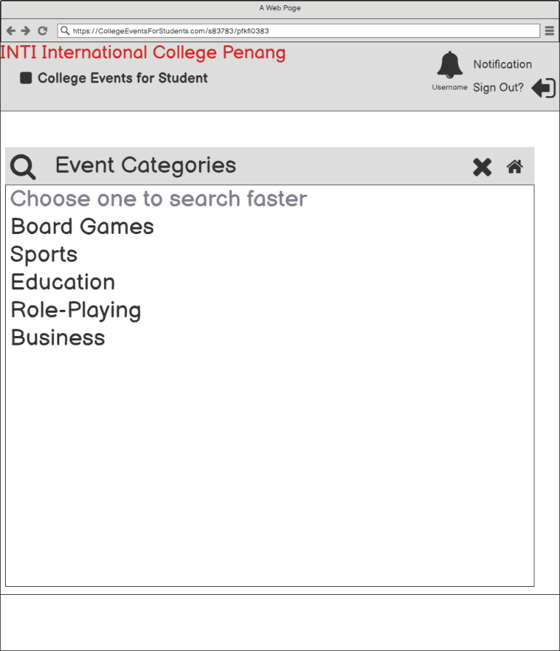

1. **Event Categories Category Results (Already Login)**

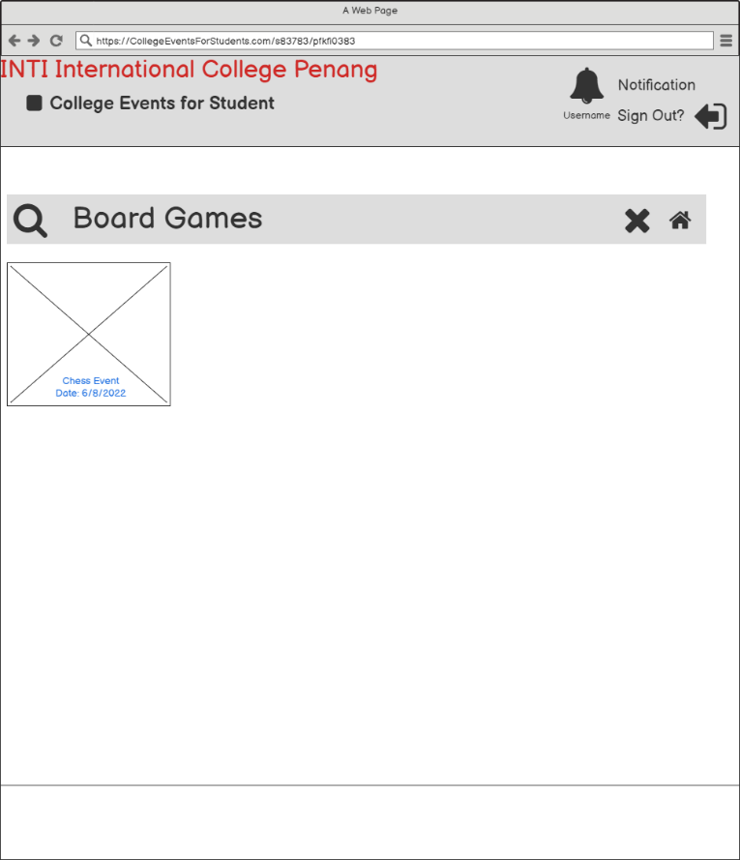

1. **Event Searching Date (Already Login)**

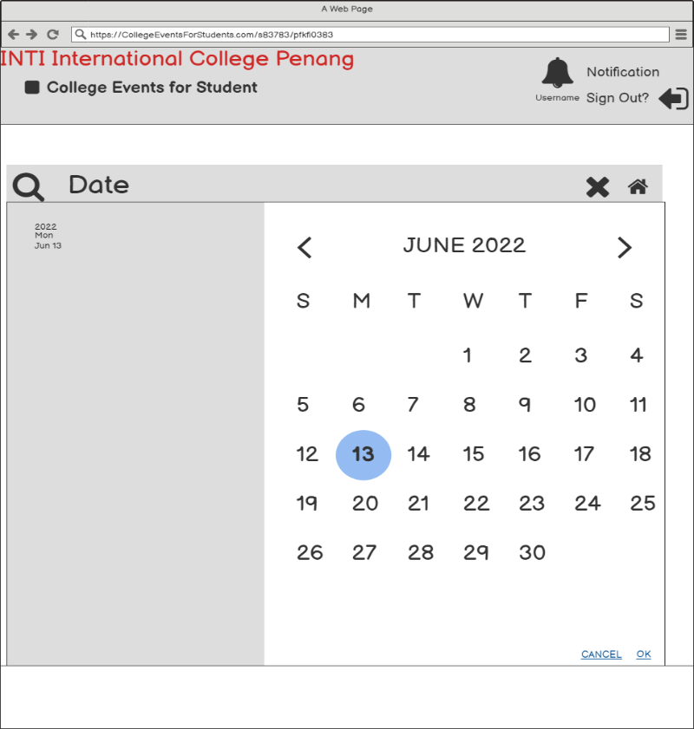

1. **Selected Date Results (Already Login)**

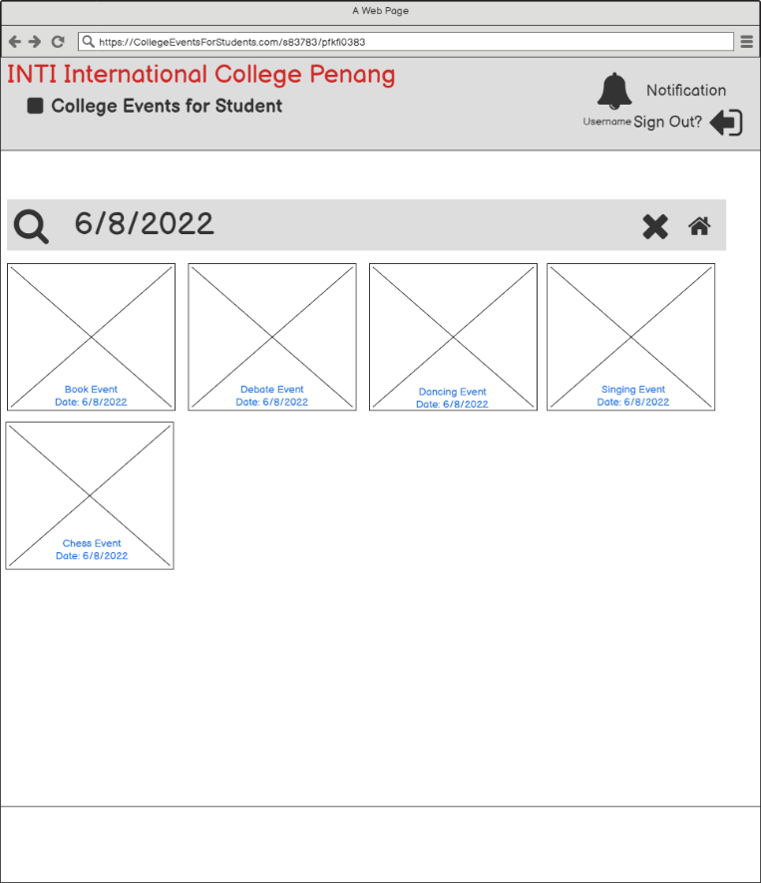

1. **Event Organiser Chat (Already Login)**

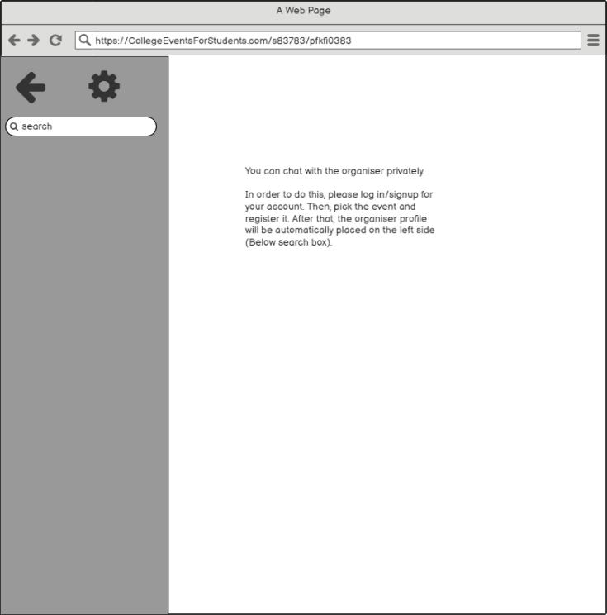

1. **Book Event (Before Login)**

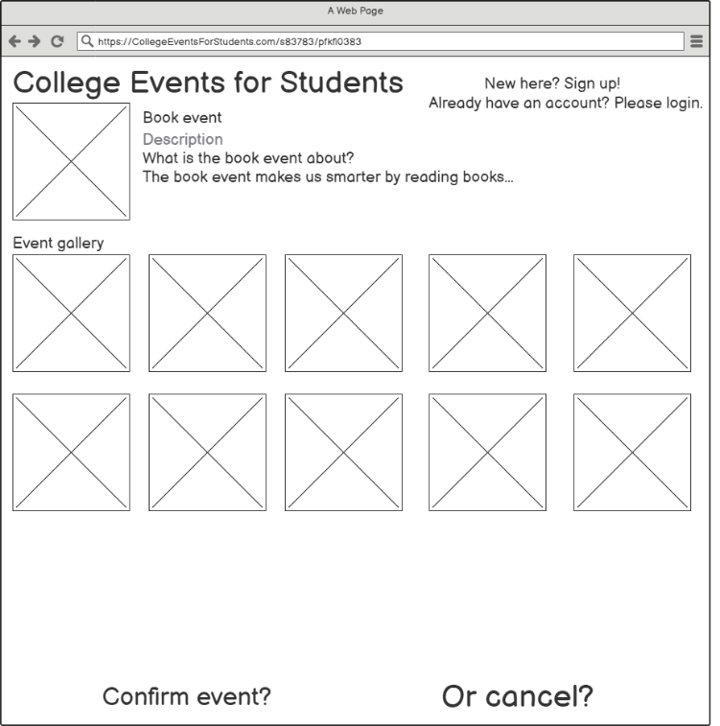

1. **Book Event (Already Login)**



1. **Registration Form**



1. **Popup Message**

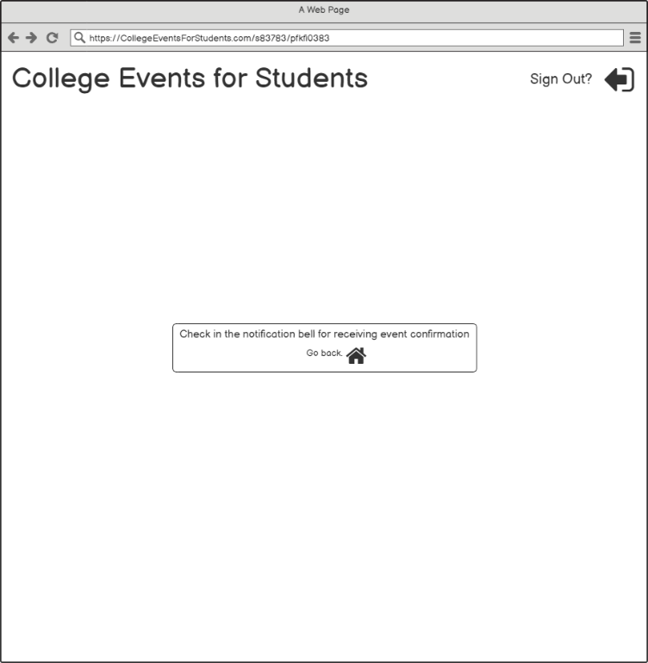

1. **Event Homepage With Event Confirmation Notification**

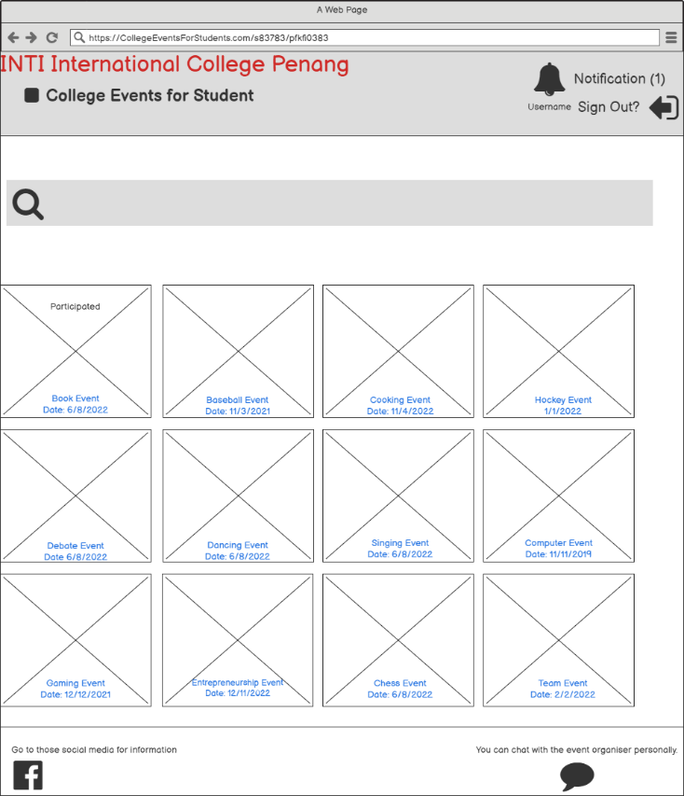

1. **Show A Popup Message If Already Participated**

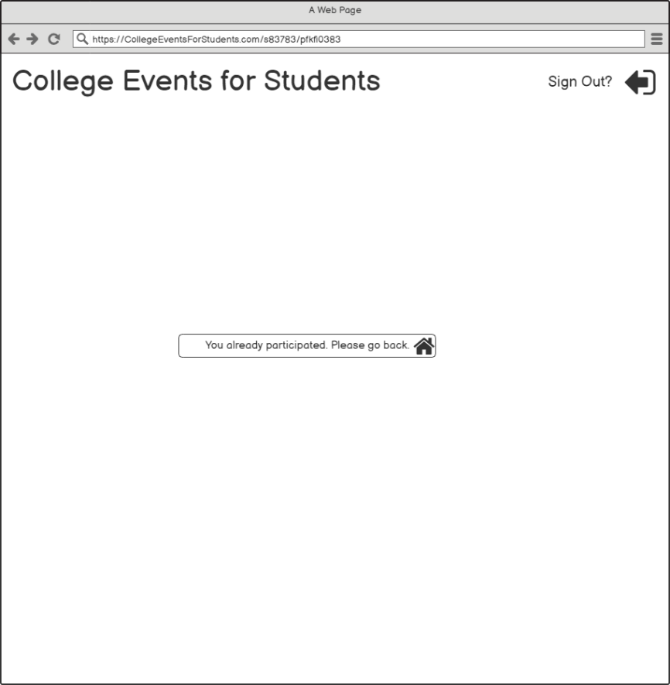

1. **Inbox With Event Confirmation Notification**



1. **Checking Event Confirmation**

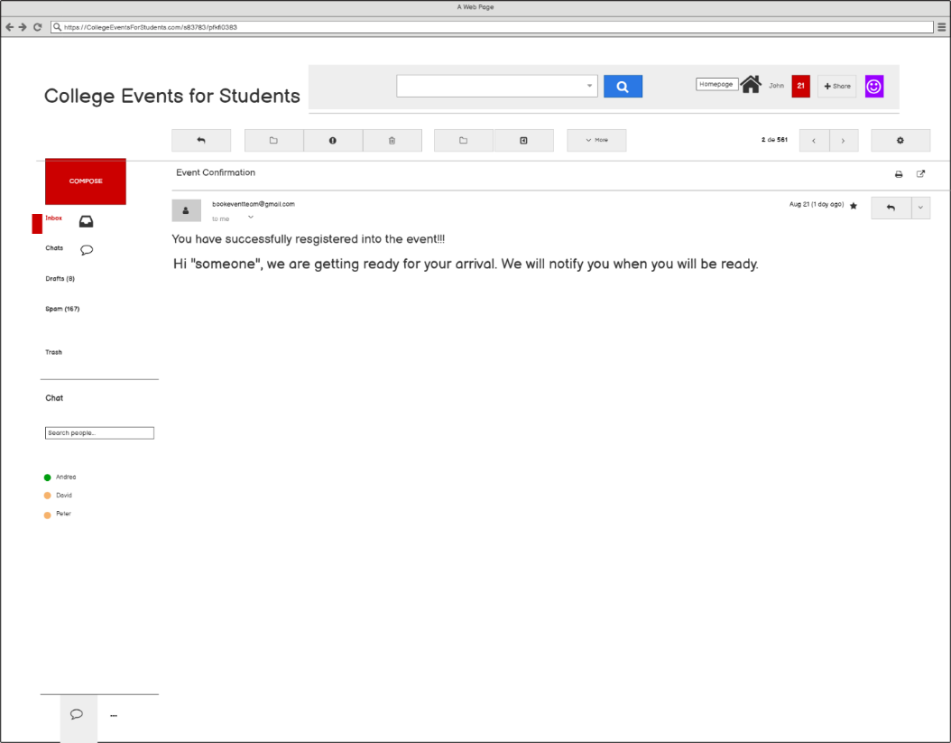

1. **Back To Inbox**

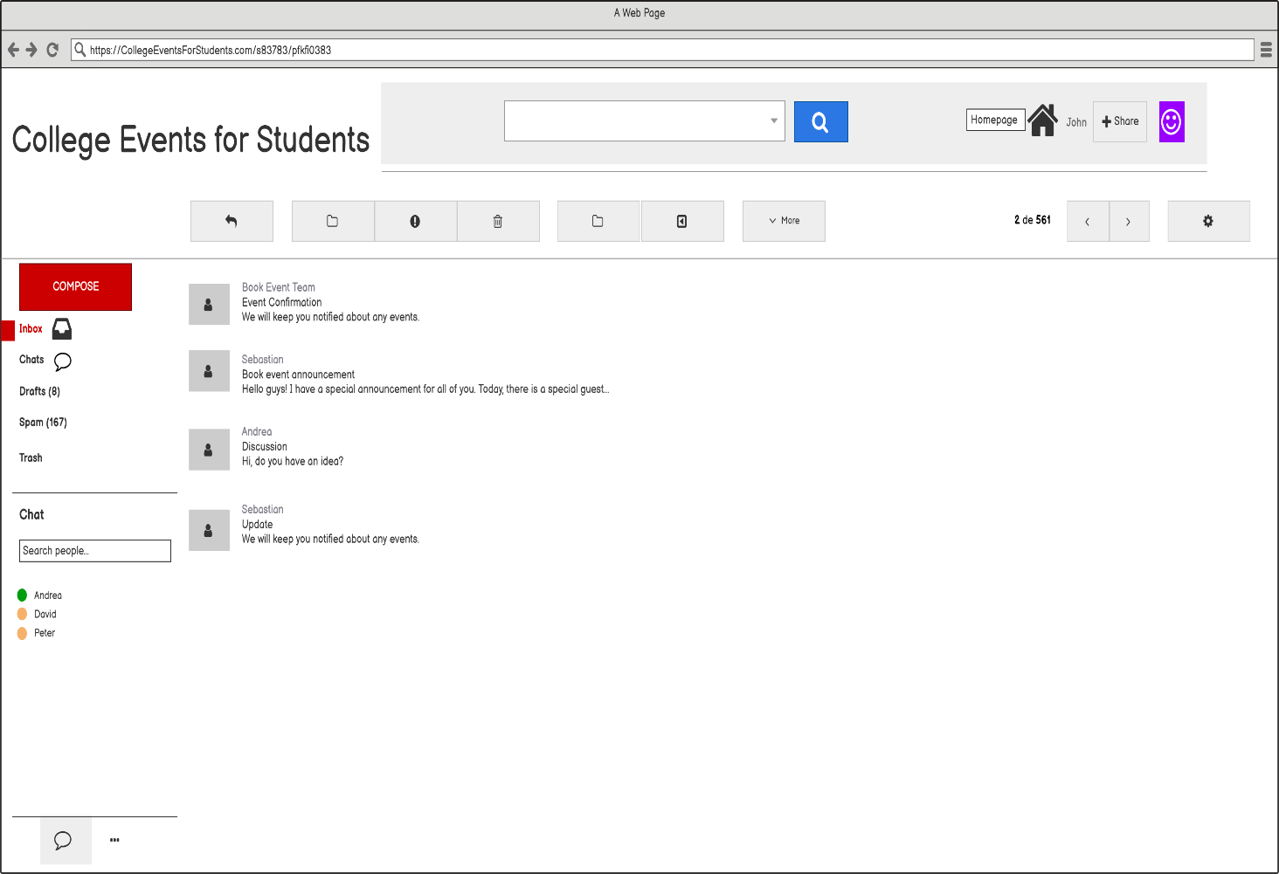

1. **Finish**

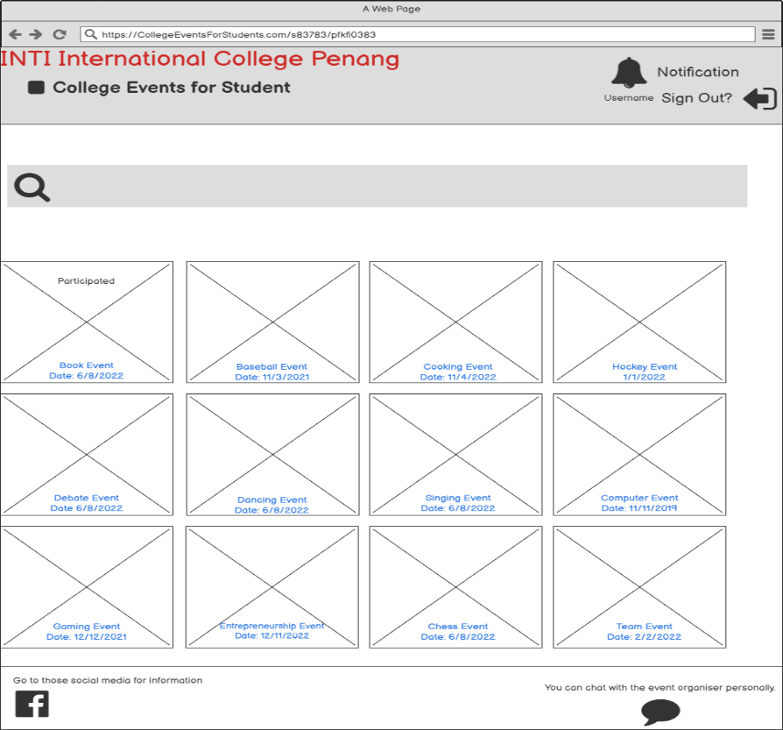

1. **Show A Popup Message If Already Participated 2**

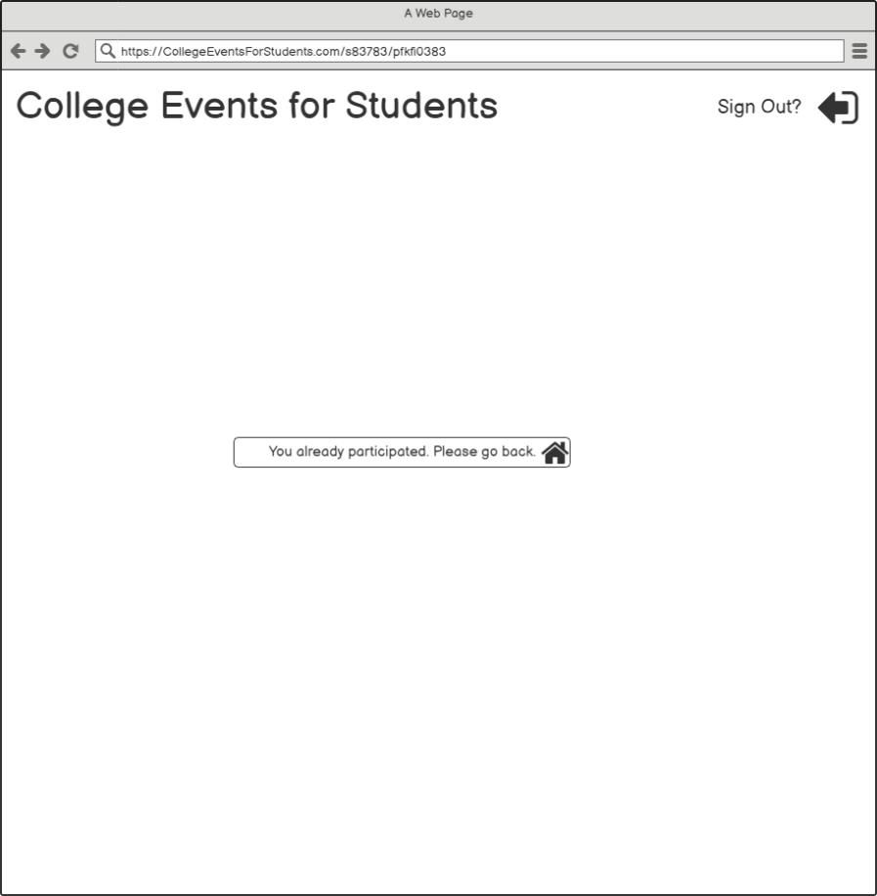

1. **Event Organiser Chat (Got A Profile)**

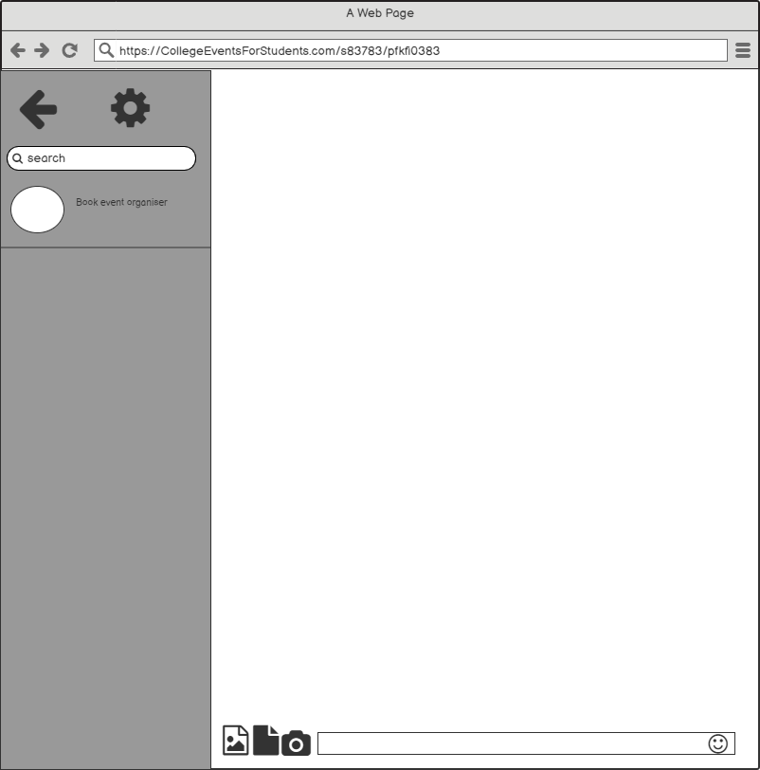

1. **Click And Chat With The Event Organiser**

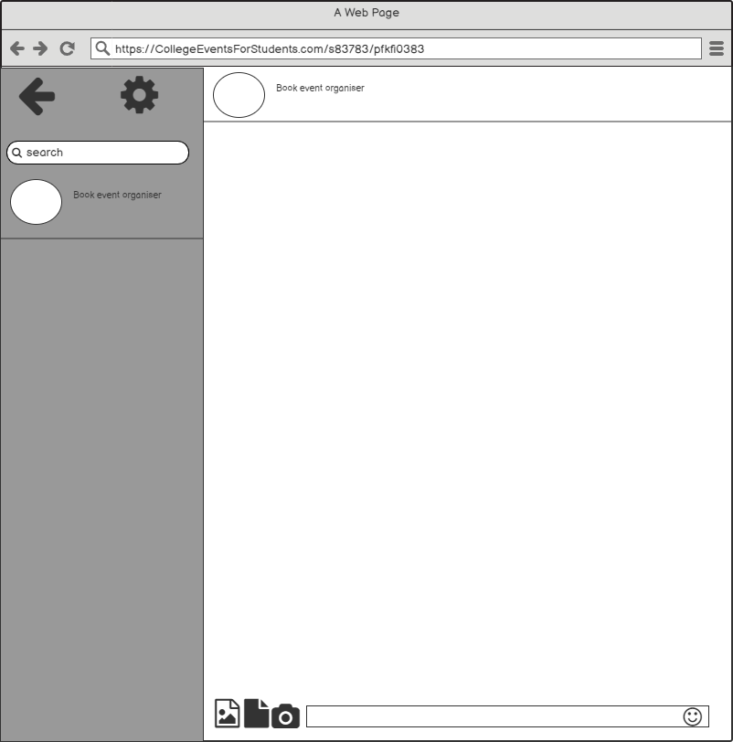

1. **Event Organiser Chat (Got A Profile) 2**



1. **Click And Chat With The Event Organiser 2**



1. **Facebook (Already Login)**

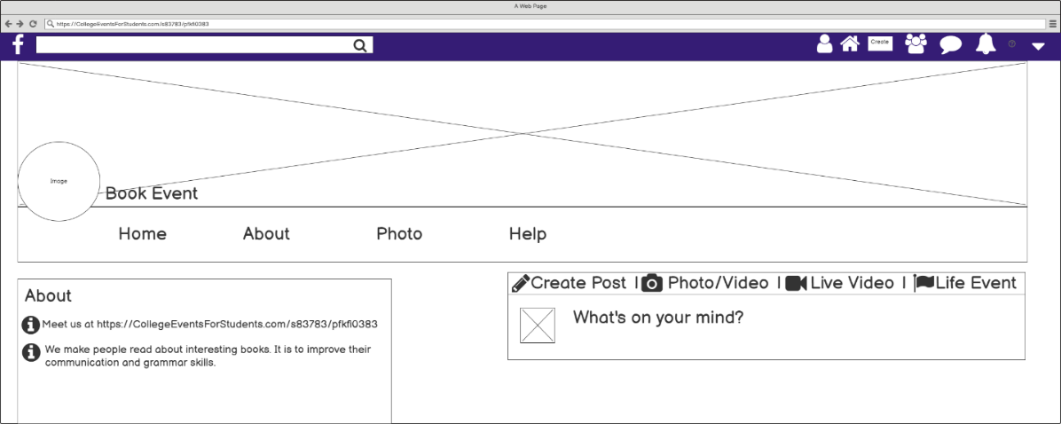

1. **Facebook (Already Login 2)**

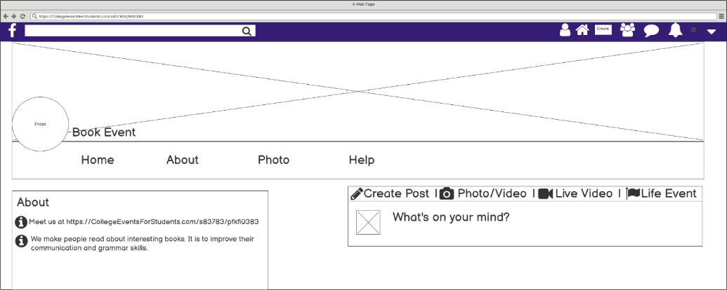

1. **Facebook (Already Login 3)**



**Link:**

<https://balsamiq.cloud/s36caj5/pkanmk9>